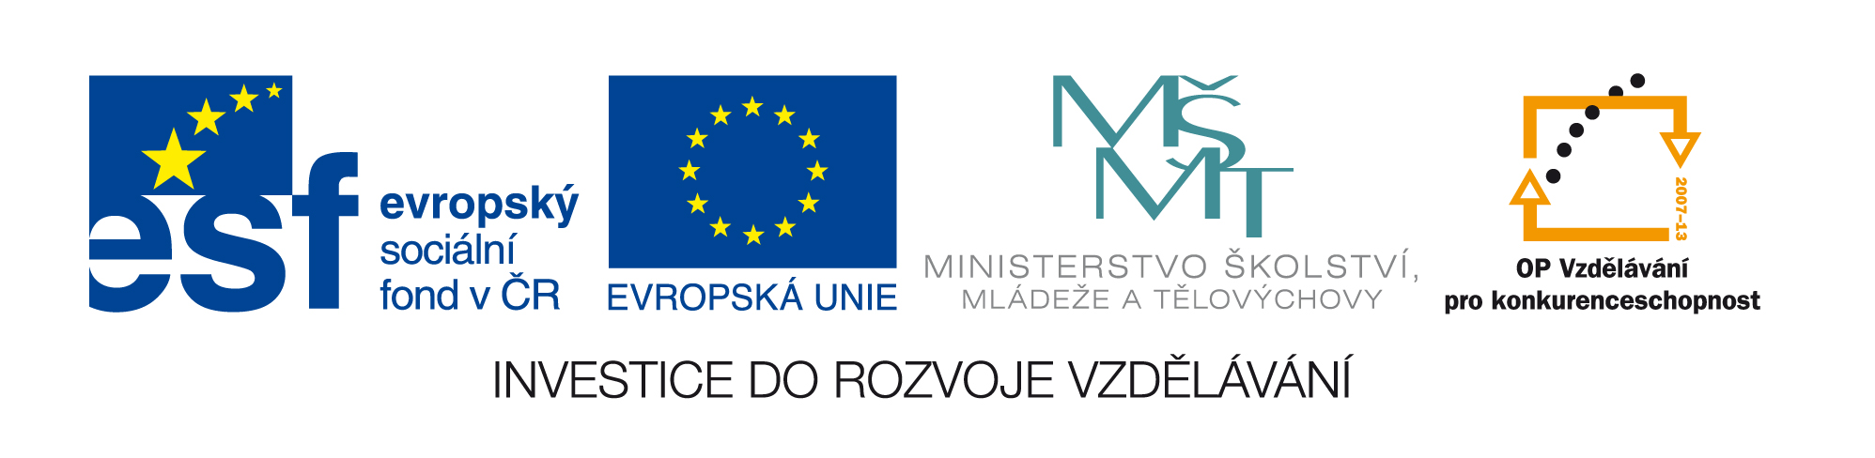

Annex to Call for tenders (number of order …)

Cover sheet

Study-stays abroad for students who have successfully completed the course TTM-S

Contracting authority

Name | Biologické centrum AVČR, v.v.i.
Address | Branišovská 31  370 05 – České Budějovice  Czech republic
Identification number | 60077344
VAT number | CZ60077344
Statutory person | Prof. František Sehnal  Director
Contact person  E-mail | Katerina Ciharova MD  katerina.ciharova@ila.cz
Applicant

Name
Address

Mailing address
Legal form of the applicant
Identification number
VAT number
Statutory person Name, Surname, Title
Telephone
E-mail
Contact person
Name, Surname, Title
E-mail
Telephone
Contract price

Total price (VAT excluded) |  | VAT | Total price (VAT included)
Structure of the price
 | Price per person (VAT excl.) | VAT | Price for 16 persons  (VAT excl.) | VAT | Price for 16 persons  (including VAT)
Transport from and to the airport
Accommodation
Full board including coffee-brakes
Lecturing
Total

Declaration of the applicant:
The applicant declares that he is Binder by the full content of the offer for the whole contracting period.

The offer of the applicant consists of manually numbered pages including the originals or verified copies of all documents.

Signature of the offer

Signature of the statutory person
Title, First name, Surname
Stamp, Date

