
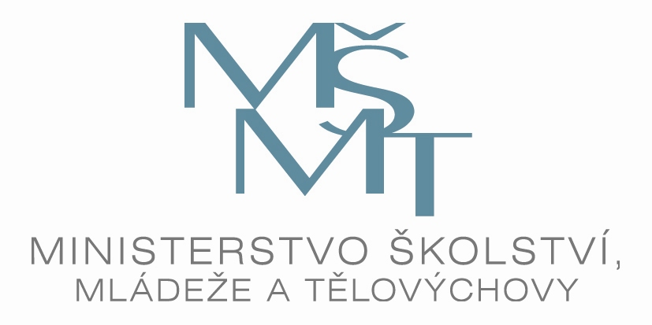
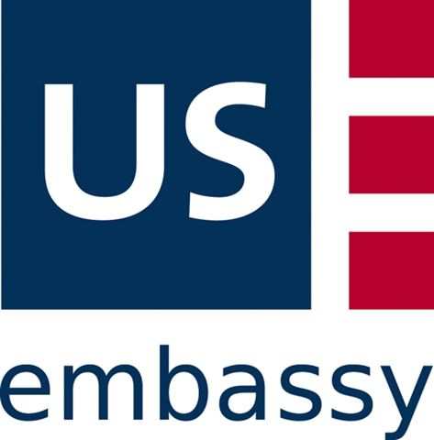
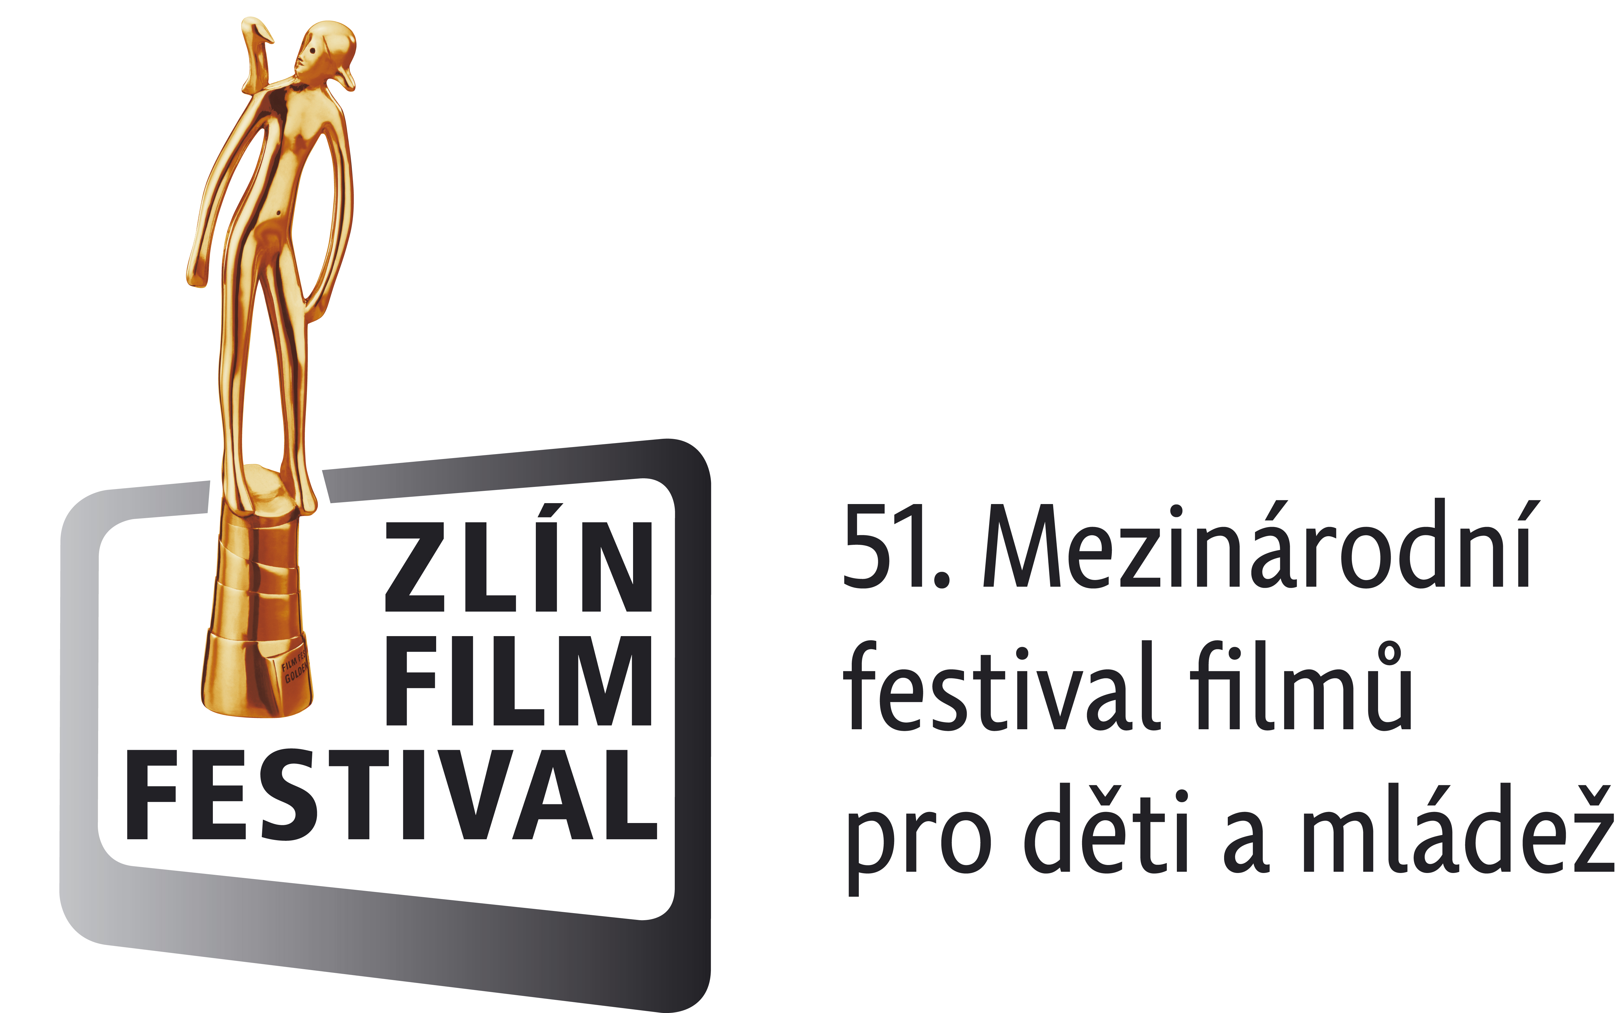

Education for all Children
Continuation of long-term international project supported
by the Ministry of Education of the Czech Republic, started in 1999

Child in Crisis
“Current Crisis of Contemporary Children“

XIII. National seminar with International Participation
Accredited by the Czech Ministry of Education (under No. 9004/2009 - 25 - 163)

Under the Patronage of
PaedDr. Alena Gajdůšková, Vice-chairman of Senate ČR
Mgr. Josef Dobeš, Minister of Education, Youth and PT of the Czech Republic
Ministry of Labour and Social Affairs of the Czech Republic
U. S. Embassy - David J. Gainer, Cultural Attaché
Prof. Ing. Petr Sáha, CSc., Rector of Tomáš Baťa University of Zlín
MVDr. Stanislav Mišák, Head of Zlín Regional Council
Doc. MgA. Petr Koliha, Art Director of FILM FESTIVAL ZLÍN 2011
on the occasion of the
INTERNATIONAL CHILDREN´S DAY
and 51st FILM FESTIVAL ZLÍN 2011
June 1 – 2nd 2011
Zlín, INTERHOTEL Moskva, Moravia, Czech Republic

Organisers and Specialist Advisors
• Organization and realization of the Project - PaedDr. Lenka Kubrichtová
• Czech Republic – professional advisor PhDr. Jana Procházková
(Clinical psychologist, Dept of psychology, College of Education, Charles University, Prague)
• UK - professional advisor Misha Fell, Chartered Child Psychologist
(Child and Adolescent Clinical Psychology, Leeds Primary Care Trust, UK)

The Seminar is prepared in collaboration with the Czech-British Foundation for Prevention of Crisis in the Family, based in Leeds, England, the Ministry of Labour and Social Affairs of the Czech Republic, Ministry of Education, Youth and Sport of the Czech Republic, County Council of Zlín region, Institute for further Education, Zlín region , FILMFEST Company and JaKu limited.

Description and Goals of the Project
The seminar with international participation Child in Crisis - „Current Crisis of Contemporary Children“ is a part of the long-term ongoing Czech-British project entitled “Education for All Children”. This Seminar has become a traditional and respected accompanying part of the International Film Festival for Children and Youth, held in Zlín every year. In 2011, the Seminar will be organized for the 13 th time.
Aim of the project is to facilitate multidisciplinary co-working in the area of child welfare and protection not only on local and national but also international context.
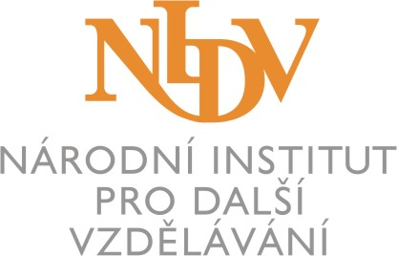



Each of the annual educational Seminars has focused on a specific area of interest:
(Praha 8. 4. 1999, Zlín 31. 5. - 1. 6. 2000, 30. - 31. 5. 2001, 29. - 30. 5. 2002, 28. - 29. 5. 2003, 2. - 3. 6. 2004, 1. - 2. 6. 2005, 31. 5. - 1. 6. 2006, 30. - 31. 5. 2007, 4. - 5. 6. 2008, 3. - 4. 6. 2009, 2.- 3. 6. 2010, 1. - 2. 6. 2011
1999: Integrating Children with their Specific Educational Needs
2000: Working Together for the Future of All Children
2001: Child in Crisis - Special Needs of Children in Crisis
2002: Child in Crisis - Helping Children in Need
2003: Child in Crisis - Interdisciplinary Cooperation in the Area of Children´s Rights
2004: Child in Crisis - Interdisciplinary Cooperation in the Area of Children´s Rights
2005: Child in Crisis - Contemporary Family and Child from the Point of View of Interdisciplinary Cooperation
2006: Child in Crisis - Child and Family within Networks of Time
2007: Child in Crisis - “Children and Family in the Changing World”
2008: Child in Crisis - “Children and Family and violence”
2009 : Child in Crisis - “Opportunities for Children….?”
2010: Child in Crisis - “Coping with Crisis”
2011: Child in Crisis - “Current Crisis of Contemporary Children”

Child in Crisis – “Current Crisis of Contemporary Children“ is a 2-day National Seminar with International Participation, supplemented by interactive Workshops with opportunities for wide discussion with Czech and international specialists from the field of education, health, police, justice, social work, and preventive and follow up care . English translation services will be provided throughout the Seminar.
Aims of the Seminar:
- To extend and enhance awarness and special skills of educationalists in the area of protecting children
- To facilitate meetings with experts from the Czech Republic, UK, Slovak Republic and other countries and provide a basis for detailed discussions of the Topic
- To enable sharing of experiences regarding children and families with relevance to topic of crisis
- To discuss and analyse the situation in this area in the Czech Republic highlighting multidisciplinary cooperation
- To introduce possibilities and issues of interdisciplinary cooperation in the area of legal protection children´s laws in Czech Republic, UK, Slovak Republic and other countries
- To introduce possibilities of interdisciplinary cooperation in this area on regional and national and international levels
- To offer to educationalists and other experts the practical possibilities of protecting child and the family
- To develop skills for practical problem solving in specific areas using model case studies
- To make available to participants a range of study materials related to the central issues covered by
this Seminar
PaedDr. Lenka Kubrichtová, PhDr. Jana Procházková
Tel.: + 420 603 257 491, e-mail: lkubrichtova@gmail.com
In Prague on 22nd February 2011

Dates: june, 1. - 2., 2011
Official Opening: 1st june 2011 , 12:30 p.m.
Official Closure: 2nd june 2011, 4:30 p.m.
Address: Interhotel Moskva – Congress Hall, náměstí Práce 2512, 760 01 Zlín
Akreditation: Academia Centrum Univerzity Tomáše Bati, Mostní 5139, 760 01 Zlín

!!! There is NO REGISTRATION FEE for this Seminar !!!
Boarding: The responsibility of each participant can be in conference hotel Moskva
Accommodation: The responsibility of each participant,
!!! Important !!! –In case you are interested in getting a reservation at your own cost at one of the festival's hotels. please fill in the Accreditation Form at www.zlinfest.cz, - ( Applications - Accreditation )
enter “Child in Crisis” in the “Film Delegation” box
Please address any queries regarding accommodation to:
FILMFEST, s.r.o., Filmová 174, 761 79 Zlín
e-mail: akreditace@zlinfest.cz,
Národní institut pro další vzdělávání, krajské pracoviště Zlín - Potoky 267, 760 01 Zlín





Bc. Zdeněk Duša, e-mail: dusa@nidv.cz, tel.: + 420 577 221 950, + 420 775 571 632
CONFIRMATION SLIP by 16th May 2011 at the latest
We would like to ask you to send the confirmation slip by as soon as possible as places get booked up , due to the fact that the Film Festival is being held on the same dates
Please send via fax to the following number: +420 2 61 91 12 63 or to this address:
PaedDr. Lenka Kubrichtová
Ke Kurtům 382
142 00 PRAHA 4
Child in Crisis
“Current Crisis of Contemporary Children“
XIII. National seminar with International Participation
Accredited by the Czech Ministry of Education (under No. 9004/2009 - 25 - 163)
Under the Patronage of
PaedDr. Alena Gajdůšková, Vice-chairman of Senate ČR
Mgr. Josef Dobeš, Minister of Education, Youth and PT of the Czech Republic
Ministry of Labour and Social Affairs of the Czech Republic
U. S. Embassy - David J. Gainer, Cultural Attaché
Prof. Ing. Petr Sáha, CSc., Rector of Tomáš Baťa University of Zlín
MVDr. Stanislav Mišák, Head of Zlín Regional Council
Doc. MgA. Petr Koliha, Art Director of FILM FESTIVAL ZLÍN 2011
Dates: june, 1.- 2., 2011 (Oficial opening at 12:30 p.m. )
Address: Zlín, Interhotel Moskva – Congress Hall, náměstí Práce 2512

! There is NO REGISTRATION FEE for this Seminar !
Accommodation and food is the responsibility of each participant.
Please, fill in with capital letters. Thank you

Name, surname, title: ………………………………………………………...

Address: ………………………………………………………...........….….…

Telephone: …………………………….. e-mail: ………………………………..
Signature: …………..……..…………….
WORKSHOPS: ( factors efecting resilience, possibilities of reinforsing,what is missing, …)
Choice of workshop (please circle)
I.Current Crisis of Contemporary Children
II. Current Crisis of Contemporary Families
III. Current Crisis in wider Environment of Contemporary Children

Contribution on topic of: ……………………………………………………………………...
(Contributions of maximum lenght of 7 minutes; please send abstract to e-mail.: lkubrichtova@gmail.com by the 16th May 2011.at the latest. )

Organization: ..............................................................................................................

Address: ......................................................................................................................

Telephone, e-mail: ......................................................................................................

