
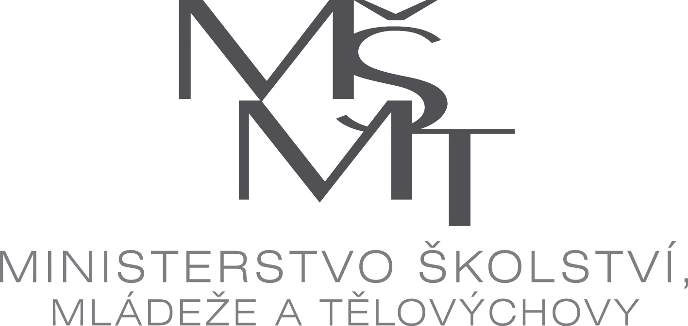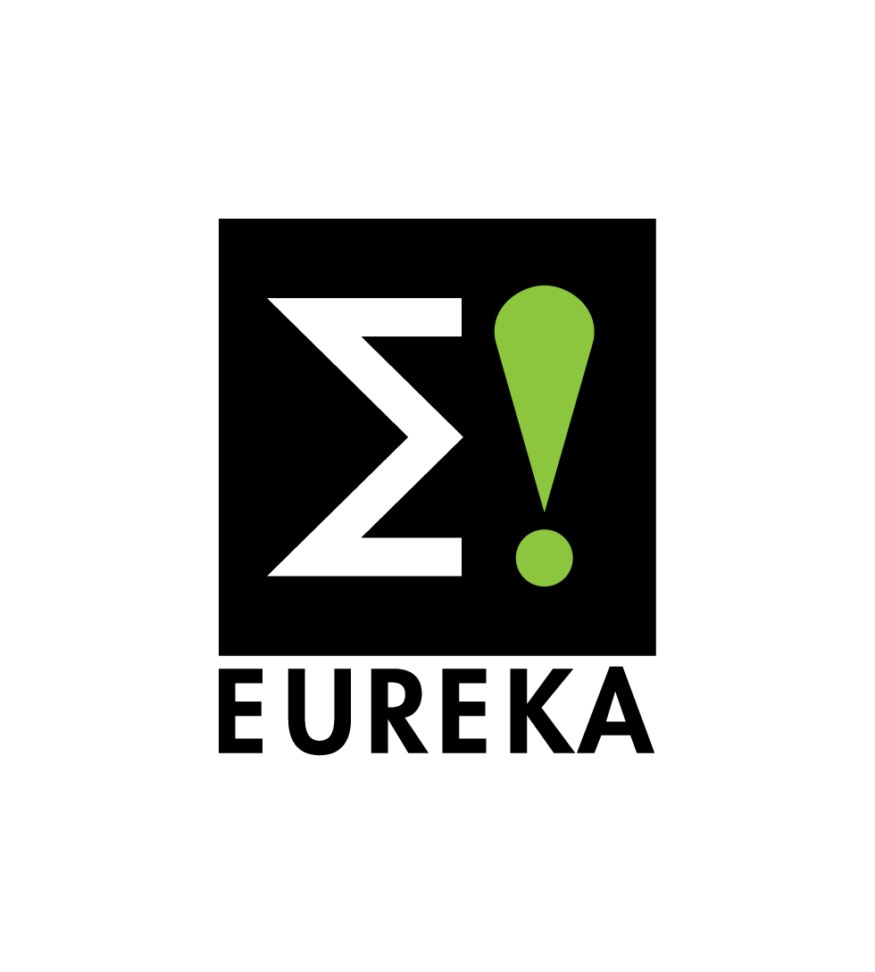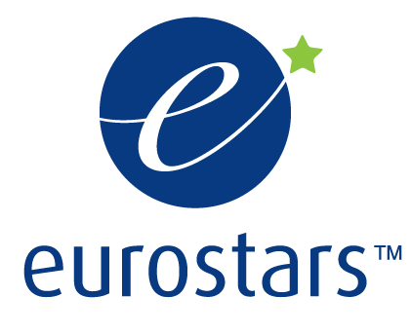

invite you to event

EUREKA B2B for R&D Cooperation
Date: 10.10.2011
Meeting Room: Karmelitská 7, 118 12 Prague 1, C 081

PROGRAMME

09.00 Registration at MEYS
09.30 Opening, Director of International R&D Department
09.40 Presentation of KIAT about S. Korean support for R&D cooperation
09.55 Czech EUREKA & EUROSTARS activities, cooperation between S. Korea and Czech Republic.
10.15 Presentation of Czech Invest
10:25 Short break
10.40 Presentation of S. Korean companies profiles (about 5 minutes per company)
11.30 Presentation of Czech companies profiles (about 5 minutes per company)

12.30 Lunch

13.30 B2B meetings
15.30 Coffee break
16.00 Results, recommendations
16.30 End

