I am delighted to be able to speak to you today and particularly at this event, which is a really important event, I think, if we want to move forward in a way we link scientific ideas with products and with the markets.

I think it is fitting to note that today Germany and France are celebrating the 50th Anniversary of the Elysee Treaty between the two countries; a treaty that remains the main engine of the European Union as we know it today.

We want Europe that is exciting, that is interesting, and that is successful; a Europe that can stand up to global challenges. How do we deliver that? Well, we deliver that by exciting science, and by good engineering and technology.

However, most of all we should be able to demonstrate that what we as scientists do, is relevant to everyday life. We need to communicate this relevance to people who fund our research, to policy makers and generally to all citizens. After all it is their taxes that is the source of most public funds.

Nothing communicates this more effectively than showing that our results have relevance to everyday life and are being translated to tangible products, services or employment. My experience from the Cambridge University fully confirms that.

European Institute of Innovation and Technology (EIT) is today powering the innovation in Europe and I am delighted to welcome here in Prague Dr Alexander von Gabain, Chairman of the EIT Governing Board. In the five years of its existence it has achieve remarkable results and it is surprising to me that somehow the Czech Republic has so far stood aside as we see on the following slide.

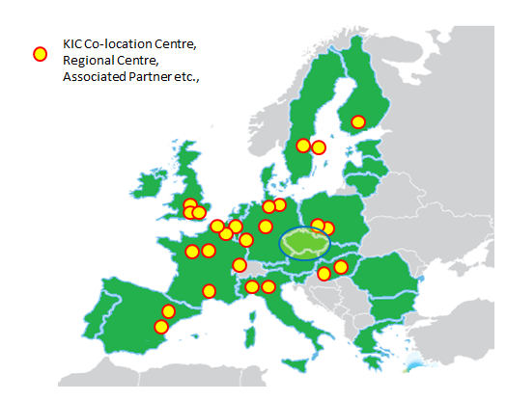

Nevertheless, let’s look forward and consider where we, as a member country of EU, can play a role in the future. Last summer the Government of the Czech Republic approved the National Priorities of Oriented Research for 2015-2030. Alignment between these priorities and potential future themes for KICs is very favourable as can be seen from this slide.

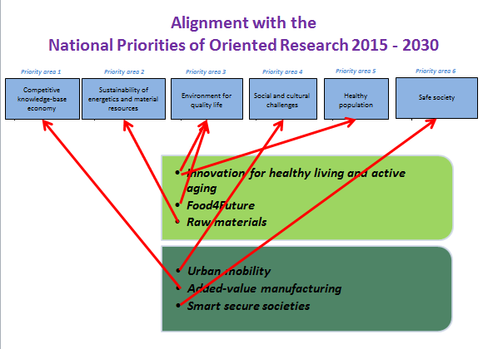

Furthermore, the Czech Republic, and in particular the Southern-Moravian region, already has excellent working contacts with the neighbouring countries (Austria, Hungary and the Slovak Republic) through CENTROPE. It therefore only depends on us whether we link our efforts and improve our participation in the future plans of EIT.

Ladies and gentlemen, I am sure we will hear a number of interesting presentations that will give rise to many new ideas. I wish you all a very successful and fruitful meeting.

Rudolf Hanka