Table of contents
INtroduction 3
The design of the piaac assessmenT 4
The main study design: An integrated approach 4
Item development needs 6
The impact of international options in the main study assessment design 7
Assessment design without reading component skills 7
Assessment design without problem solving in technology-rich environments 8
Implementation Timeline of PIAAC 10
Overview 10
Phase one: Project initiation 10
Phase two: Instrument development and validation 11
Phase three: Instrument assembly and systems integration 12
Phase four: Train and conduct field test; analyse results 13
Phase five: Finalise instruments; train and conduct main survey 14
Phase six: Analysis and reporting 14
The structure AND ROLE of national centres 16
National level project management and coordination 16
National Project Manager (NPM) 16
National Quality Control Monitor (NQCM) 17
IT coordinator 17
National steering or coordination groups 17
Project implementation 18
Submission of items and stimulus material for the direct assessment 18
Sampling 18
Translation and adaptation of instruments and questionnaires 19
Training 19
Preparation of data set for transmission to contractor 21
Quality control 21
Technical support 21
Preparation of national report 21
Survey organisation 21
Communication 22
Annex A: Hardware requirement 23
Annex B: Qualifications of leading survey organisation 24

INtroduction
The Programme for the International Assessment of Adult Competencies (PIAAC) is conceived as an international, multi-year programme focusing on the assessment of adult skills and competencies. Its primary objectives are to: a) develop direct measures of competencies believed to underlie both personal and societal success; b) assess the impact of these competencies on social and economic outcomes at individual and aggregate levels; c) gauge the performance of education and training systems in generating required competencies; and d) help to clarify the policy levers that could contribute to enhancing skills.
PIAAC is a collaborative venture involving participating countries. At the international level, a Board of Participating Countries (BPC) is responsible for the overall policy aspects of the programme, including the design, assessment instruments and reporting. At the national level, PIAAC is implemented through a National Project Manager (NPM) who will take overall responsibility for the implementation of PIAAC following the international guidelines and standards accepted by the BPC. National expertise and participation are important components of PIAAC and as such, experts from participating countries serve on working groups that link objectives with the best available expertise in the field of international comparative assessments of educational outcomes.
The design and implementation of PIAAC, within the framework established by the BPC, is the responsibility of an international consortium consisting of Educational Testing Service (ETS), Westat, cApStAn, the ROA at the University of Maastricht, ZUMA, the German Institute of Institutional Educational Research (DIPF), and the International Association for the Evaluation of Educational Achievement (IEA). The PIAAC consortium is also responsible for the technical aspects of implementation within countries including the development of instruments, management of data collection, analyses of data, quality control, support to and supervision of countries during the implementation process as well as contact with the OECD and countries during the reporting phase.
The purpose of this document is to provide an overview of the components involved in implementing PIAAC in national centres, including the assessment design, timeline, and main activities. Additionally, the description of tasks may serve as guidelines for countries to estimate resources and national costs.

The design of the piaac assessmenT
The design of the PIAAC assessment is complex. PIAAC measures four domains—literacy, numeracy, reading components, and problem solving in technology-rich environments—through two modes of administration—paper-and-pencil and computer. The target population is that of adults aged 16-64 and the assessment is designed to take approximately 60 minutes. As the intent of PIAAC is to have its results linked to previous international adult assessments, 60 percent of the numeracy and literacy tasks will come from ALL and IALS, while 40 percent will be newly developed tasks designed to reflect any refinements and extensions to these frameworks. Reading components and problem solving in technology-rich environments will consist of new tasks that are mapped to their respective frameworks.
Also implicit in the assessment design, but not addressed by this document, is the administration of a background questionnaire that will collect additional information about the sampled adults, including demographics, educational background, labour market experiences, and skills use. This questionnaire is expected to take between 30-45 minutes and is administered (at least in part) before the cognitive assessment through a computer-assisted interview approach.

The main study design: An integrated approach
The design of the PIAAC assessment takes into account the broad range of abilities among participating countries along with various policy needs, including an interest in focussing on highly skilled adults and/or those segments of the population demonstrating limited abilities. This is accomplished in PIAAC through the use of multi-stage testing. Countries with higher proportions of lower skilled adults and/or those reporting less computer familiarity receive the paper-and-pencil booklets measuring literacy, numeracy and reading components at relatively higher rates. Alternatively, countries with relatively larger proportions of higher skilled and/or more computer familiar adults are more likely to traverse the computer-delivered path in the multi-stage design, requiring them to respond to measures of literacy, numeracy and problem solving in technology-rich environments.
The main survey design is based on a minimum main study sample size per country of 5,000 adults aged 16-64. Countries have the option to increase sample size to obtain reliable estimates for groups of special interest.
This design provides good measurement on the full range of direct assessment measures included in PIAAC and provides a baseline for assessing trends or changes over time in future rounds of PIAAC or similar assessments. Initial information from the background questionnaire is used to direct respondents to one of two branches (and formats) of the assessment (see Figure 1). Respondents uncomfortable or unfamiliar with using computers will be directed to the paper-and-pencil branch of the assessment while the remaining adults will be directed to the computer-delivered branch. It is expected that in each participating country the majority of adults will respond to the computer-delivered instruments but the actual percentage is likely to vary from country to country. Nevertheless, both the paper-and-pencil and the computer-delivered measures of literacy and numeracy will cover the full range of each construct so that highly literate and highly numerate adults will be able to demonstrate their proficiencies regardless of whether they respond in the paper-and-pencil or computer-delivered formats.
The paper-and-pencil branch will include a 10-minute core assessment of literacy and numeracy skills. This will be followed by a 30-minute block of either literacy or numeracy items and a 20-minute assessment of their component skills. Adults will be randomly assigned to respond to either the literacy or numeracy items before taking the component skills measures. The small proportion of respondents (likely to range from 2-5 percent in most countries) who fail to correctly answer the majority of tasks in the core will skip the literacy and numeracy items and be routed to receive the component skills measures. This is similar to the procedures followed in IALS and ALL where adults who failed the core did not take the full assessment due to their demonstrated level of literacy and numeracy proficiencies.
The computer-delivered branch of the assessment is comprised of a complex staging process that directs individuals to the literacy, numeracy or problem solving sections of the assessment. Individuals following the computer branch are first directed to respond to the core items. If they perform poorly on these core tasks, they will be automatically directed to respond to the paper-and-pencil component measures. Individuals who perform at or above the minimal standard will be randomly assigned to either a two-stage adaptive measure of literacy or numeracy that requires approximately 25 minutes to complete or to a 25-minute block of problem-solving tasks. Following the first 25-minute block of either literacy or numeracy, half of the respondents will be directed to the alternate domain, ensuring that they respond to literacy and numeracy items presented in two different orders. The other individuals will be guided to a second set of problem-solving tasks based on their responses to the items in the literacy or numeracy clusters. A portion of individuals who take the problem-solving block first will be directed to either a numeracy or literacy block while the other portion of individuals will be directed to a second set of problem-solving tasks. The proportions of respondents and mechanisms for direction of the respondents to the assessment clusters will be derived from analyses of the field test data. The branching procedures will be designed in such a way that the amount of information collected for each skill is optimized across the range of proficiencies.

Figure 1. PIAAC main study integrated assessment design
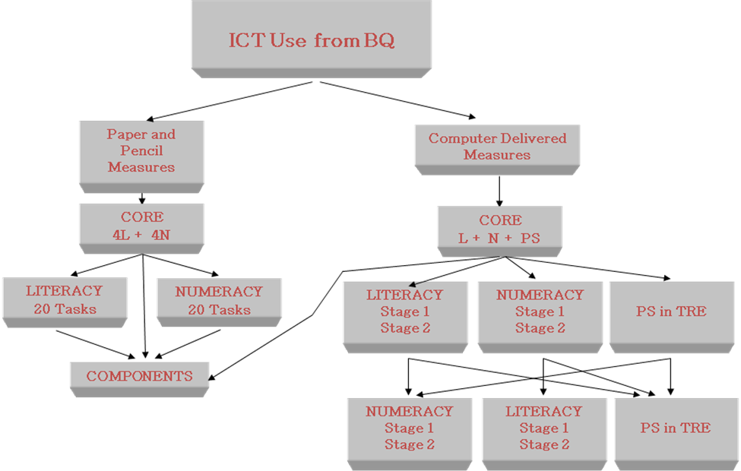
In summary, this design provides the following information:
- Component skills among lower performing adults in each participating country as well as among those who report not being familiar with using a computer;
- Population distributions in literacy, which can be linked to IALS/ALL;
- Population distributions in numeracy, which can be linked to ALL;
- Accurate estimates of population distributions and a baseline measure of problem solving in technology-rich environments for estimation of trend over time;
- Strategies and processes that adults use when responding to the problem solving in technology-rich environment tasks;
- Pair-wise covariance estimates among the various measures including the relationships between literacy and numeracy; literacy and component skills, literacy and problem solving, numeracy and component skills; and numeracy and problem solving; and,
- Information which can be used to analyze the relationship between the measured competencies and PIAAC's affective measures and social/economic measures (from the responses to the background questions and JRA modules).

Item development needs
The field test and main study item needs for literacy and numeracy are shown in Table 1. Overall, the main survey will require 24 items for the paper-and-pencil version and 48 items for the computer-based version for each domain. Linking items refer to items selected from IALS and ALL that will be used to establish the link between PIAAC and these previous studies. The field test will require a total of 35 paper-and-pencil literacy and 35 paper-and-pencil numeracy items. The computer version will need 72 items for each domain. Of these, 42 will be used to evaluate their utility as linking items for the computer-delivered measures while a subset of 25 will be used to evaluate their utility for the paper-and-pencil format.
Table 1. Literacy and numeracy item needs for PIAAC
Literacy / Numeracy | Field Test |  | Main Study
Literacy / Numeracy | Link | New | Link | New
Paper Version | 25 | 10 | 19 | 5
Computer Version | 42 | 30 | 29 | 19
The assessment of problem solving in technology-rich environments involves scenarios of varying levels of complexities and lengths. Scenarios will be designed to take between 5 and 15 minutes to complete. Overall, 150 minutes of testing material will be developed for the field test (approximately 16 scenarios of varying lengths) and 50 minutes of testing material will be considered for the main study (approximately 8 scenarios of varying lengths). The scenarios finally selected for the main survey will be organised into two 25-minute blocks.
Reading component measures will also be developed according the framework. Typically these measures focus on speed and accuracy and several measures can be assessed in a limited amount of time. A total of 20 minutes will be allotted for the main survey to measure these skills with final measures assembled from 40 minutes worth of field test data.

The impact of international options in the main study assessment design
The OECD and participating countries have identified the assessments of literacy and numeracy as core components of PIAAC. Core components are taken by all participating countries and will be an area of focus in the international report that will be prepared by the OECD. In addition, participating countries have identified the assessment of reading components and problem solving in technology-rich environments as international options. Although these are internationally managed and implemented, countries will be able to choose whether or not they wish to include these domains as part of their national assessment. It was agreed that countries have until October 2008 to make final decisions with regards to these options. The two alternative designs for countries choosing to opt out of these domains are described below.

Assessment design without reading component skills
This option represents a version of the integrated design that does not include the assessment of reading component skills. To help overcome for the loss of accuracy among examinees in the lowest ability range, this design increases the number of literacy and numeracy items that are administered to examinees in the paper-and-pencil branch of the assessment. Examinees who are branched to the paper-and-pencil booklets and pass the 10-minute core tasks will respond to a lengthened set of literacy and numeracy tasks. One group will first respond to a set of literacy tasks followed by a set of numeracy tasks, while the other group will respond to a set of numeracy tasks followed by a set of literacy tasks. This optional design will require the full 60 minutes allotted for the direct measure of skills and will require the same minimum sample size of 5,000 adults. It is illustrated in Figure 2.
Figure 2. PIAAC main study design, without reading components
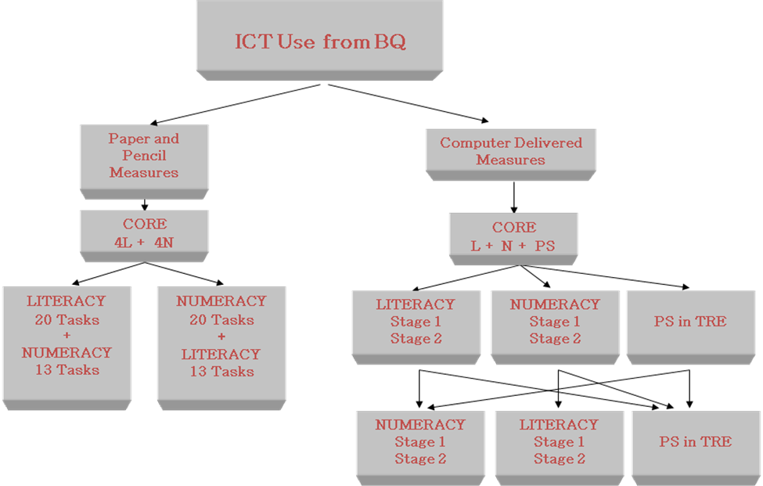

Assessment design without problem solving in technology-rich environments
This option, shown in Figure 3, represents a version of the integrated design that does not include the assessment of problem solving in technology-rich environments. Adults who pass the 10-minute core set of tasks will be directed to either a 25-minute 2-stage set of literacy or 2-stage set of numeracy tasks. This would be followed by another set of tasks. Those who responded to the literacy tasks first would be directed to take the numeracy tasks next while those who first responded to the numeracy tasks would receive the literacy tasks. Since countries will not be reporting on the distribution of problem solving in technology-rich environments, they could reduce their minimum sample size from 5,000 to 4,500 adults ages 16-64.
Figure 3. PIAAC main study design, without problem solving in technology-rich environments
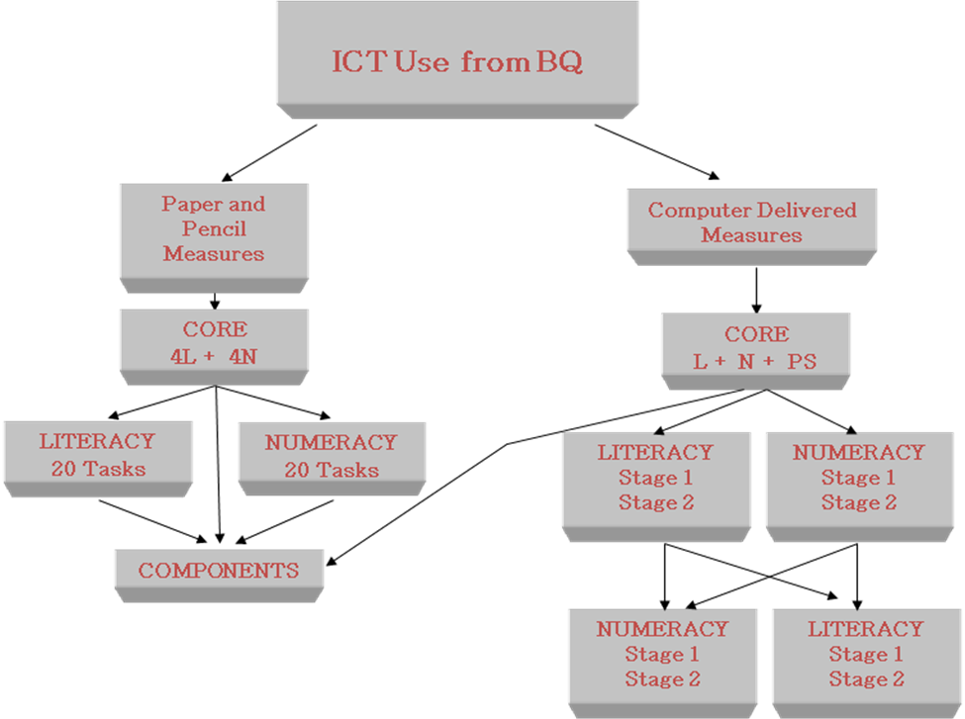

Implementation Timeline of PIAAC

Overview
The timeline established for the implementation of PIAAC is challenging due to innovative approaches for test design that include two modes of administration as well as characteristics associated with the household approach. PIAAC assesses literacy, numeracy, and problem solving in technology-rich environments using computer-based and paper-based assessments. In parallel, it also collects background information through a computer-based interview approach. The programme of work was officially established in March 2008 and the key dates include the field test data collection in 2010, the main study data collection in 2011, and reporting of the international results in March 2013.
The implementation of PIAAC has been organised into six phases that include: a) the project initiation; b) instrument development and validation; c) instrument assembly and system integration; d) training and conducting the field test, and analysing the field test results; e) training and conducting the main study; and, f) scaling, analysing, and reporting the main survey results. The overall timeline of PIAAC, focusing on the consortium’s perspective, has been presented previously in other documents. Therefore, the purpose of this section of the document is to emphasise implementation aspects from a national perspective, to facilitate the organisation of national centres and to assist them with the implementation process.

Phase one: Project initiation
The first months of the project will focus on setting up the management structure and coordination activities of the project. Within countries, this phase means setting up their national centres and nominating their national project manager. During this time, countries will receive general information about important aspects of PIAAC, including the overall timeline, assessment design, the role and responsibilities of national project managers, upcoming activities, and information on how to enrol in and access the secure project Web site.
Communication between the OECD, participating countries and the consortium will be enhanced through the web-based communication tool. This will ensure that everyone has access to meeting documents, the project calendar and other relevant information on a timely and secure fashion. As a secure site, countries are advised to limit access to a few individuals.
Table 2 shows the main activities for countries for phase one and approximate timelines for these activities.
Table 2. Activities and tasks for phase one of PIAAC
Activities and tasks | Date
Phase one: Project initiation | March – May 08
- Understand the roles and responsibilities of national project managers (NPM) | March – April 08
- Understand the assessment design and the impact of international options | March – April 08
- Review the assessment design | April 08
- Attend BPC/NPM introductory meeting | April 08
- Nominate National Project Managers | May – June 08
- Register for the web-based communications tool | May – June 08

Phase two: Instrument development and validation
Phase two represents a busy and important period for national centres. It involves the development of the assessment instruments, which includes national contributions to this process through item submissions, revision of the item pool, revision and commenting on the final frameworks, and translation and adaptation of instruments and manuals.
Instrument development includes the background questionnaires as well as the direct assessment in both paper- and computer-based formats. Representatives from each participating country are expected to attend the first full meeting of national project managers (June 17-20, 2008), where they will be presented with the overall goals of the project, the tasks and responsibilities of national centres, overviews of each assessment framework, item writing workshops, translation and verification procedures, and procedures for sampling, survey operations, and quality control. The computer-based aspect of PIAAC gives countries the option of submitting items in the computer platform. Consequently, national project managers will be offered a workshop on using the Hypertext Builder (HBT), the authoring tool that can be used for developing items for TAO which is the delivery platform for both the background questionnaire and the direct assessment.
The item writing workshops and item submission periods enhance countries’ knowledge about the framework and build national capacity. Countries can be involved in the item submission process through the submission of items and/or stimuli in English, French, German, Spanish, Japanese and Italian. Texts and items that are submitted by countries will be translated (if necessary) and reviewed by the consortium, the relevant expert group, and later all participating countries. This will ensure that the field test item pool adequately represents the framework in terms of the various aspects or task characteristics, and are culturally and linguistically acceptable among all participating country. Once reviewed, the field test item pool will be authored into the computer-delivered platform, the paper booklets will be designed and countries will begin translating the instruments.
Table 3 shows the main activities for countries for phase two and approximate timelines for these activities.
Table 3. Activities and tasks for phase two of PIAAC
Activities and tasks | Date
Phase two: Instrument development and validation | March 08 – Sep 09
- Attend first NPM meeting (Main topics: discuss overall goals of PIAAC, conduct sampling consultations, review frameworks, and conduct workshop on the assessment platform) | June 08
- Attend item development workshops | June 08
- Attend training on the Hypertext Builder authoring tool | June 08
- Develop and submit new items for the direct measures. Authoring items in TAO using hypertext builder is optional for countries | June – Sept 08
- Review frameworks for literacy, numeracy and the background questionnaire | Oct 08
- Review the framework for problem solving | Nov 08
- Attend second NPM meeting (Main topics: conduct workshop on translation and verification guidelines, review procedures for item review, and conduct sampling consultations) | Oct 08
- Receive training in item translation and verification | Oct 08
- Translate and verify items for the field test | Nov 08 – June 09
- Review item mapping reports for the direct measures as well as for the background questionnaire and JRA module | Feb – Mar 09
- Attend third NPM meeting (Main topics: review items and background questionnaire for the field test, conduct sampling workshop for the field test, discuss quality control procedures, and review final survey operations, standards and guidelines) | Mar 09
- Review the BQ and JRA reports | Mar 09
- Review item mapping reports for the background questionnaire | Mar 09
- Review and comment on item selection for the field test | Mar 09
- Translate assessment instruments | Mar – June 09

Phase three: Instrument assembly and systems integration
This phase of the project will focus on the finalisation of the instruments, from a technical point of view. Although most of the responsibility will rest with the consortium, countries will be involved in this phase by authoring the instruments following translation, testing the system, verifying that it is functioning well, and making sure it works well in conjunction with their information management system.
Table 4 shows the main activities for countries for phase three and approximate timelines for these activities.
Table 4. Activities and tasks for phase three of PIAAC
Activities and tasks | Date
Phase three: Instrument assembly and systems integration | June – Dec 09
- Assemble the assessment instruments in all languages | June – Oct 09
- Conduct user testing of the integrated computer delivery platform | Sep – Dec 09

Phase four: Train and conduct field test; analyse results
This phase of the project will focus on activities for the field test. Countries will be trained on the procedures for the field test to ensure that it will be implemented in a consistent fashion across households and across countries. Quality control is an important facet of PIAAC and countries are expected to implement and follow quality control procedures. These will be introduced at the first NPM meeting in June 2008 and reinforced throughout the project. Following the administration of the survey, countries are responsible for scoring various tasks, for preparing their database, and for assisting the consortium by answering queries related to their data.
Table 5 shows the main activities for countries for phase four and approximate timelines for these activities.
Table 5. Activities and tasks for phase four of PIAAC
Activities and tasks | Date
Phase four: Train and conduct field test; analyse results | Dec 09 – Oct 10
- Attend fourth NPM meeting (Main topic: prepare for the field test) | Dec 09
- Finalise instruments for the field test and verify that the system functions as intended | Dec 09
- Train for the field test | Dec 09
- Implement field test data collection | Mar – May 10
- Score field test data and produce database | Mar – June 10
- Participate in the cleaning of the data file by answering queries | June – Sep 10
- Verify field test data | Aug – Dec 10
- Attend fifth NPM meeting (Main topics: review field test results and prepare for the main study) | Nov 10

Phase five: Finalise instruments; train and conduct main survey
This phase of the project will focus on activities for the main study, and will focus on many of the same activities as those undertaken to prepare for the field test. Countries will be trained on the procedures for the main study to ensure that the survey will be implemented in a consistent fashion across households and across countries. In addition to the tasks from the field test, the main study will also include international quality monitoring activities. After the administration of the survey, countries will be responsible for assisting the consortium by answering data queries and for preparing their national database. This phase also includes preparation of the national survey operations report and final documentation of the main study.
Table 6 shows the main activities for countries for phase five and approximate timelines for these activities.
Table 6. Activities and tasks for phase five of PIAAC
Activities and tasks | Date
Phase five: Finalise instruments; train and conduct main survey | Oct 10 – Nov 11
- Review and comment on cognitive instruments and background questionnaires for main study | Dec 10
- Complete sampling and quality control plans for main study | Oct – Dec 10
- Appoint and train national quality control monitors (NQCM) | Sep – Dec 10
- Appoint international quality control monitors (IQCM) | Sep – Dec 10
- Training of the international quality control monitors | Jan 11
- Attend sixth NPM meeting (Main topics: prepare for the main study) | Jan 11
- Training for main survey | Jan 11
- Implement main data collection | Mar – Oct 11
- Attend seventh NPM meeting (Main topic: review sampling, implementation procedures, and dissemination strategies) | Oct 11
- Main scoring and database production | Mar – Nov 11

Phase six: Analysis and reporting
This phase of the project is likely to be the most rewarding for countries as they will review their data, prepare a dissemination strategy, organize national reporting, and review the international reports. The final three NPM meetings will concentrate around the methodologies for analysing the results, the construction of indices, and reporting and dissemination strategies. Most importantly, this phase includes familiarisation with and training on appropriate use of the data files including the two data tools – the data explorer and the data analyser.
Table 7 shows the main activities for countries for phase six and approximate timelines for these activities.
Table 7. Activities and tasks for phase six of PIAAC
Activities and tasks | Date
Phase six: Analysis and reporting | Oct 11 - Mar 13
- Clean main study data files and prepare database | Nov 11 – Mar 12
- Attend eighth NPM meeting (Main topics: review preliminary results from main study, finalise plans for indicator construction, and finalise analysis plans for international scaling) | Mar 12
- Review preliminary data | Mar 12
- Prepare dissemination strategy | Mar 12 – Mar 13
- Attend ninth NPM meeting (Main topics: review final report on survey operations for main study, train on the use of data files and data tools, and finalise reporting and dissemination strategy) | Oct 12
- Attend tenth NPM meeting (Main topics: review main study sample weighting and variance estimation results, train on using data explorer) | Feb 13
- Receive training on the data analyser and data explorer | Mar 13
- Final release of PIAAC results | Mar 13

The structure AND ROLE of national centres
The structure and role of national centres will vary according to the size and administrative arrangements of countries as well as on the availability of human and financial resources. Consequently, national costs will also vary widely between participating countries, depending on the manner in which countries chose to implement PIAAC (e.g., use of national statistical office or a commercial contractor). In some countries, responsibility for the national implementation of PIAAC will rest with a single ministry while in others it will be shared among various branches of the government. Some countries may choose to manage PIAAC through a coordinating committee involving the national stakeholders. Others may sub-contract the implementation of PIAAC to another organisation (e.g., a research institute or survey organisation).

National level project management and coordination
Whatever the organisational structure chosen to conduct PIAAC nationally, countries will need to establish a national infrastructure for the coordination and management of PIAAC. National centres are responsible for ensuring that PIAAC is implemented following detailed international guidelines and standards that yield comparability and quality of the outcomes. In addition to the management, coordination and communication tasks, national centres are responsible for drawing national samples, translating and/or adapting survey instruments and questionnaires, coordinating the administration of both the field test and the main survey, managing the technology issues, preparing and submitting a national data file to the consortium, reviewing national and international results, and preparing national reports. At a minimum, this will involve establishing the positions of a National Project Manager (NPM), National Quality Control Monitors (NQCM), an IT coordinator, and national committees or coordination groups to support specific aspects of the survey.

National Project Manager (NPM)
Countries are expected to appoint a National Project Manager (NPM). The NPM is expected to be employed for the duration of the project and to devote the majority of his/her time to the position. The role and responsibility of the NPM is described in the document COM-DELSA-EDU-PIAAC(2008)5. The NPM will be responsible and accountable for ensuring that the implementation of PIAAC in their country follows the guidelines and international standards approved by the BPC. The NPM will also be the consortium’s primary contact point within each country. He or she will coordinate, manage and communicate appropriate information to various governmental organisations, individuals, and contractors. NPMs are expected to attend two annual meetings (costs for their participation are covered by the countries) and any other meeting/training sessions. The timeline and main topics of NPM meetings are identified in a previous section of this document.

National Quality Control Monitor (NQCM)
Each participating country will be required to hire and train National Quality Control Monitors (NQCM). The role of the NQCM is to monitor and report on the administration of the assessment during both the field test and main study by interviewing selected interviewers and calling a percentage of the PIAAC participants after the administration to verify that the survey took place. The work of the NQCM will be concentrated around the periods of data collection activity. It would be advisable to assume that the NQCM will need to devote up to two weeks full-time work to the field test and up to a month full-time to the main study.

IT coordinator
Each participating country is expected to nominate an IT coordinator who will be responsible for PIAAC’s information technology related activities in their country for the interaction with their national contractor. The IT coordinator will act as the primary point of communication throughout the project regarding the information technology aspects of the project. The IT coordinator should be knowledgeable about IT and familiar with survey operations in their country. The work of the IT coordinator will be concentrated in the periods of IT development and data collection. During these periods, it is expected that the IT coordinator will work full-time on PIAAC. The IT coordinator will have direct responsibility for the following activities:
- Obtain sufficient laptop computers to support the survey operations. These computers must meet the minimum technical requirements established by the consortium (with technical specifications as set out in the Annex A) and they should be dedicated to the PIAAC project during the conduct of the field test and main survey operations.
- Configure these laptops with survey software to consortium specifications.
- Provide training to interviewers in the operation of the laptops and the survey software. NPMs and related staff should expect to receive training in the survey software including the Hypertext Builder that can be used to author items for the background questionnaire and cognitive instruments.
- Provide a national Helpdesk for technical support for the interviewers during the survey administrations.
- Extract survey data from laptops and manage the formatting and cleaning of this data for delivery to the consortium.

National steering or coordination groups
Participating countries may wish to establish a formal national steering mechanism for the project involving ministries or other agencies with an interest in PIAAC and/or a scientific advisory committee. These individuals provide national input to the review phases of the project and assist on any development aspect that may emerge (i.e., review of frameworks, item development, analytical reviews).

Project implementation
The aims of PIAAC are: a) to develop reliable and valid measures of adult competencies; b) enable the continuity with and links to the two previous international adult assessments; c) broad both the set of skills that are measured as well as how they are measured; d) extend the range of information provided to policy makers; e) embed quality control throughout the project; f) enhance communication among all participants in PIAAC; g) encourage and assure international participation and collaboration in all aspects of the project; and, h) introduce innovative and efficient aspects to an international survey. In order to meet these requirements, the implementation of PIAAC is complex, follows a strict timeline, and requires international cooperation in following strict criteria and procedures. Countries participate throughout the development and implementation phases of the survey.

Submission of items and stimulus material for the direct assessment
Participating countries are encouraged to submit items to increase the linguistic and cultural representation of the data pool. The costs of this will be relatively low. Item submissions are accepted in six languages: English, French, German, Spanish, Italian or Japanese; countries will be responsible for translating submissions from other languages.

Sampling
As a household survey, PIAAC includes complexities related to sampling and administration of survey instruments to selected adults residing within households. Each participating country has agreed to obtain a sample that will be representative of its national population aged 16 to 64 years, with oversampling possible at the national level for particular cohorts of the population. Explicit standards for obtaining representative samples will be provided and discussed during meetings and through private consultations the consortium will have with countries. These will begin at the June 2008 NPM meeting and will occur both before the field test and the main surveys. Each country will need to draw a high-quality probability sample representing the adult non-institutional civilian population aged 16 to 64, with some small percentage of exclusions possible.
Participating countries will have to develop a sampling design for both the field test and main study. This will be developed on the basis of the guidelines provided by the international contractor. The sampling design will need to ensure that a representative sample of the adult population (16-64) is selected to be interviewed and tested. Subject to approval from the international contractor, countries may also wish to include an option to oversample specific sub-groups within this population or extend the sample to the older population (65+).
The main costs related to sampling will be the costs of employing a sampling expert or experts to undertake the sample design and coordinate with the NPM and international contractor. This will involve identification of a sample frame, decisions regarding exclusions (e.g., households in very remote areas), determination of the appropriate stratification of the sample and specification of selection processes for households and individuals within households. Countries should expect to devote up to a month of a sampling expert’s time to this task including the participation of a sampling expert at up to three NPM meetings.

Translation and adaptation of instruments and questionnaires
Instruments and questionnaires will be available in English. Countries will be responsible for translating and/or adapting the instruments and questionnaires into their target language(s) to be used in testing. The bulk of the translation/adaptation task will occur prior to the field test. However, further translation may be required after the field test reflecting changes made for the final instruments.
A range of documentation will be produced for PIAAC, including survey standards and procedures and training materials. These will be produced in English. Translation into national languages is the responsibility of participating countries.
Countries will also have to verify the questionnaire items and, within the guidelines established by the international contractor, submit any national adaptations that might be required to take account of their own national circumstances. For example, countries may wish to substitute the standard PIAAC questions with their own specific questions for obtaining information on educational attainment, occupation and industry. There will also be scope, but very limited, for additional specific national questions such as on ethnicity, for example. Any proposed adaptations would have to be submitted to the contractor in English for approval.

Training
Training for national staff relating to the implementation of PIAAC for national staff will be provided at both the international and national levels.
At the international level, training will be provided by the international contractor. This training will be designed primarily to train those national staff that will lead in-country training. Participating countries will have to finance the attendance of national staff at international training sessions. Training sessions are planned relating to the use of the TAO authoring system, sampling, survey operations, translation and adaptation and the use of PIAAC analysis tools.
At the national level, the replication of training following the international guidelines will be the responsibility of participating countries. Training materials will be provided by the international contractor. It is expected that countries provide training for data collection staff in the PIAAC procedures prior to both the field test and main study.

Data collection and preparation
Data collection will take place both during the field test in early 2010 and the main study in 2011. The data collection will consist of face-to-face interviews and testing of individuals representing the adult population randomly selected according to the agreed upon sampling design.
While the fixed costs of establishing the infrastructure for the implementation of data collection will be significant, sample size and the time an interviewer spends obtaining completed cases will also affect survey administration costs.
The main parameters countries should keep in mind in estimating costs are set out below for the field test and main study.

Field test
- Sample size: Minimum of 1,100 to 1,450 completed cases within the age group 16-64.
- Duration of the interview/assessment session: 90-105 minutes.
- Hardware: dedicated laptops (with technical specifications as set out in the Annex A) - One per interviewer plus spares in case of breakdown.
- Printing: assessment booklets for respondents taking the pencil-and-paper version of the assessment.
- Coding and scoring: 400 cases undertaking pencil-and-paper assessment. Some scoring of the problem solving tasks may also be required.

Main study
- Sample size: Depending on the choice of country concerning the international options for inclusion in the direct test, a minimum of 4,500 to 5,000 completed cases within the age group 16-64. Each country will need to make its own decision, and factor in the costs accordingly, about setting sampling sizes above these minima. For example, a larger sample size would be required if a country wishes to oversample youth, specific ethic groups or the older population or to generate reliable regional estimates.
- Average duration of the interview/assessment session: 90-105 minutes.
- Hardware: dedicated laptops (with technical specifications as set out in the Annex A) – one per interviewer plus spares in case of breakdown.
- Printing: assessment booklets for respondents taking the paper-and-pencil version of the assessment. This will vary according to the level of familiarity with the use of computers in participating countries.
- Coding and scoring of paper-and-pencil versions of assessments: will vary between countries depending on the level of familiarity with computers. Some scoring of the problem solving tasks may also be required.
- Response rates and representativeness of results: The international contractor will set minimum standards that must be achieved in terms of response rates and the representativeness in order for the national results to be accepted. Thus, the survey organisation must be prepared to ensure that sufficient resources are devoted to reaching and interviewing sampled respondents. This may involve the use (and cost) of incentive payments as well as repeated visits to the respondents households and other follow-up contacts.

Preparation of data set for transmission to contractor
Participating countries will be responsible for the preparation of an initial data set containing the results of the field test and main study data collections for submission to the international contractor.
Data preparation time and costs will vary depending on the proportions of the national samples undertaking the assessment in pencil-and-paper format (which will require manual coding and scoring) and whether countries weight their own data.
Weighting will be conducted by the contractor. However, some countries may choose to weight their own data. Participating countries will need to check and verify the data and weights produced by the contractor. This process may involve several iterations.

Quality control
The quality assurance procedures for PIAAC involve both a national and an international component. The international component is undertaken by the international contractor. The national component will involve the NQCM undertaking interviews with data collection staff and interviewees regarding the conduct of the assessment and reporting on the results.

Technical support
Participating countries will be primarily responsible for the resolution of operational issues regarding the conduct of the PIAAC within their country. This will include resolving hardware issues (replacing/repairing interviewer laptops), survey operations (assigning cases to interviewers, resolving interviewer questions, resetting cases to a prior state, removing data from a laptop), resolving most questions regarding the content of the study, and for tracking and reporting issues encountered with the computer platform or applications.
It is recommended that that each participating country establishes a designated PIAAC Helpdesk with contact information provided to each of their interviewers and supervisors during the period of survey administration (field test and main study). Helpdesk staff should be familiar with the PIAAC computer platform and applications and training materials. Staff members working in the helpdesk should attend the interviewer training sessions so they gain the benefit of using the applications and appreciating the challenges faced by the interviewing staff.

Preparation of national report
Participating countries will bear the costs of the production of national analytic reports from PIAAC. The costs will depend on the extent of analysis to be undertaken and the length and format of the publication.

Survey organisation
The survey organisation appointed in each country must be capable of, and have a track record in, conducting national probability-based surveys to the highest standards of rigour by means of face-to-face interviewing. All contenders should be required to submit proposals and budgets according to the specification of the survey. They will also need to be made aware that for this survey they may have to change or adapt some of their routine procedures and methods in order to use the propose TAO platform for interviewing and testing and to ensure cross-national comparability and equivalence. Annex B includes detailed criteria for selecting the organisation. Overall, the following should be considered:
- Conformity with technical specifications for the implementation of PIAAC.
- Previous experience of carrying out nationally representative surveys of households.
- Previous experience in carrying out tests of literacy.
- Performance in terms of response rates in previous relevant surveys conducted by the organisation.
- Briefing and training of interviewers.
- Mechanisms to ensure high quality coding and data preparation.
- Previous track record on delivery.
- Use of and experience with CAPI methods.
- Value for money.
- Economic and financial strength of the organisation.

Communication
The NPM is the primary contact for the PIAAC consortium in participating countries. The consortium is in constant communication with the OECD Secretariat and communicates with the Board of Participating Countries through the OECD Secretariat. The primary source of information for BPC and NPM members on implementation issues will be the secured project Web site that will host all relevant materials, meeting documents, calendar, and contact information for all partners who are involved in PIAAC. Among other things, this Web site will contain up-to-date calendars, schedules and deliverables, lists of meetings and their documents, and will be used to inform everyone about progress and accomplishments, activities, key problems and solutions, as well as any unresolved issues. The consortium will also maintain a password-protected workspace for each participating country. This proprietary area will be used to document and communicate with each country about operational issues that include: translation and verification of all instruments, and preparation of test booklets and questionnaires.
Annex A: Hardware requirement
The hardware required for the conduct of the PIACC data collection will be a laptop from a major hardware vendor. The required minimum configuration for the laptops will be:
- 1.5 GHz processor;
- OS: Microsoft Windows 2000 or later, (possibly Mac OS X or Linux (kernel 2.6.x) on special request);
- 14 inch or greater colour screen;
- 1024 x 768 (XGA) resolution;
- Modem, network, or wireless interface (depending on specific country management system interfaces required);
- 10 GB free space on Hard Disk;
- Batteries with minimum 2 hour run-time;
- USB Interface; and,
- A CD/RW or DVD Drive.
Annex B: Qualifications of leading survey organisation
The success of the PIAAC will depend on the experiences and capabilities of the prime survey organisation responsible for implementation of the survey in each country. While in some countries this organisation may represent the governmental organisation responsible for PIAAC, in other cases, this may represent subcontractors.
In either case, the selected organisation that will implement PIAAC:
- must assume the responsibility for all aspects of the implementation of the PIAAC survey in the participating country; and
- should bring together a project team to carry out the PIAAC survey. If the organisation does not have expertise and/or experience in all the activities necessary to conduct the PIAAC survey, it must enlist the services of other organisations or consultants to meet the survey needs. Consequently, each national project team should consist of the prime survey organisation or group of organisations and consultants, whose combined expertise constitute the essential skills and knowledge in the areas outlined below.
A country’s prime survey organisation should have the following qualifications:
- experience in collaborating with other institutes/organisations/agencies within its own country as well as in other countries;
- successful completion of at least two national probability surveys, each with a considerable sample size of several thousand, ideally, 4,500 to 5,000 completed interviews;
- if possible, experience in conducting surveys involving assessments;
- substantial practical survey experience in the following areas;
- survey management,
- probability sample design, and sample selection,
- in-person household data collection,
- computer-assisted personal interviewing (CAPI),
- instrument and materials translation/adaptation,
- interviewer training,
- achieving high response rates in household surveys,
- maintaining data confidentiality,
- data processing, including data capture, coding, and editing, and
- sample weighting and estimation;
- ability to keep key staff on the PIAAC team for the duration of the main survey, including a project manager who will be responsible for the overall management of the PIAAC project within the participating country,
- ability to obtain assistance from key specialized staff for the duration of the main survey, including:
- a senior survey statistician, responsible for the participating country’s sample design and implementation, weighting and estimation, and regular data analysis;
- a data collection manager responsible for the hiring, training, monitoring and quality control of data collection staff, and the implementation of data collection procedures to minimize both item non-response and unit non-response, secure sufficient number of interviewers to conduct over 5000 interviews within a limited time;
- a scoring supervisor and scoring staff for scoring the paper-and-pencil version of the assessment;
- an information technology manager responsible for the set up and maintenance of the computer delivery system for the PIAAC instruments, integration with the organisation’s field management system, and support for data collection activities; and
- a data processing manager, responsible for data capture, coding, editing, and tabulation of survey results.
Each participating country should review the qualifications of each leading organisation selected to determine the merits of each organisation and their adherence to the aforementioned standards. Adaptations or deviations may be possible if they achieve the overall quality objectives of PIAAC.
The qualification data should include:
- corporate experience of conducting surveys similar in size and scope to PIAAC that includes description of survey content, name of sponsor, sample size, field staff requirements, use of computer-assisted interviews, response rates achieved; and
- qualification of key persons to be employed.

The OECD and the BPC are exploring two options for the use of French in PIAAC. The first is to provide a French translation of the instrumention to participating countries. The second is to use both French and English in the source versions of the instruments and questionnaires and require countries to independently translate from both source versions when developing versions of the PIAAC instruments in national languages.
Overall, the time to complete a case is longer than the interview session. This includes the time traveling to and from the household, following up on cases before they are considered as non-responses, reporting to supervisors on the status of work, entering administrative information into the system, editing work, and preparing files for submission among other tasks. This extra time should be considered in estimating costs.

