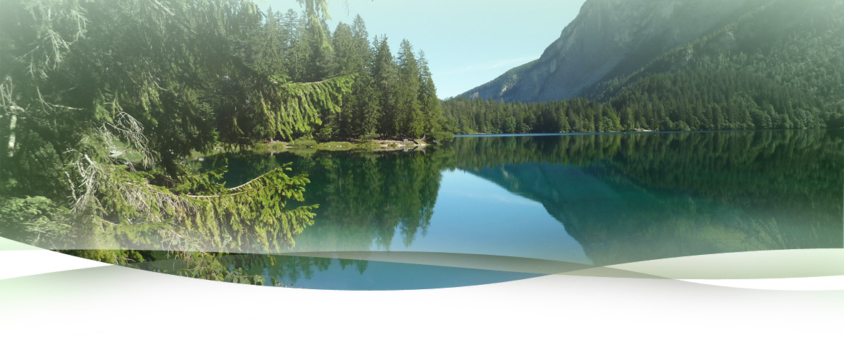

CZECH – GERMAN CONFERENCE
ON RESEARCH INFRASTRUCTURES
From exploring cooperation opportunities
towards strategic partnerships


III. Panel: environmental sciences

Coordinators:

Prof. Dr. Michal Marek
Director of CzechGlobe – Global Change Research Centre
Academy of Sciences of the Czech Republic

Prof. Dr. Alfred Wiedensohler
Head of Department for Experimental Aerosol and Cloud Microphysics
Leibnitz Institute for Tropospheric Research

PART I
Exploring Cooperation Opportunities
Presentation of Research Infrastructures

14:00 – 14:45 Overview of Environmental Research Infrastructures Specialising
on Climate, Air and Algae Research in the Czech Republic
Michal Marek, Director of CzechGlobe – Global Change Research Centre of the Academy of Sciences of the Czech Republic

14:45 – 15:30 Overview of German Environmental Research Infrastructures Landscape
Alfred Wiedensohler, Head of Department for Experimental Aerosol and Cloud Microphysics, Leibnitz Institute for Tropospheric Research

15:30 – 16:00 Coffee Break

PART II
Exploring Cooperation Opportunities
Identification of Cooperation Fields

16:00 – 16:15 Opening Remarks

16:15 – 17:00 Moderated Discussion on Topics

- Cooperation of environmental research infrastructures in ESFRI defined areas
- Exchange of best practices of environmental research infrastructures
- Exchange of research infrastructures personnel, researchers and students
- Possibility of utilization of research infrastructures from the users of other country
- Utilization of research infrastructures by Czech and German industry
- Teaming and twinning of Czech and German partners

17:00 – 17:15 Wrap-up

PART III
Towards Strategic Partnerships
Determination and Implementation of Cooperation Funding Opportunities

10:00 – 10:15 Opening Remarks

10:15 – 11:15 Moderated Discussion on Topics

- EU funding tools supporting strategic partnerships (Horizon 2020, ESIF)
- Czech and German resources for financing research infrastructures cooperation

11:15 – 11:30 Wrap-up

