Brussels, 19 November 2004



INFORMATION TOOLS ON THE EUROPEAN CONSTITUTION

On 18 June 2004, the Heads of States or Government of the 25 Member States reached agreement on a Treaty establishing a Constitution for Europe. This Constitution expresses a determination to act together. It reflects not only common values of the European Union, but also the desire to preserve individual identities. Only the support and the participation of the 450 millions citizens who make up the European Union will make this Europe a reality.

Regardless of the method chosen to ratify the Constitution (referendum or parliamentary consent), it is essential to inform and to explain its content in order for citizens to understand and to express their views freely in the public debate.

Therefore, factual information tools are being produced. They are intended for the use by the public as well as in the framework of the following operations:
- The operation « 1000 debates on Europe » with elected representatives,
- The operation « European Spring Day » with young people and educational circles,
- The operation « Journalists Seminars » with medias.

  - Graphical design and logo
  - Video
  - Brochures for citizens
  - Panels
  - Fact sheets
  - Accessories
  - Power point presentations

All these tools are available on the website dedicated to the European Constitution:
http://europa.eu.int/constitution

- LOGO « A CONSTITUTION FOR EUROPE »

The logo « A Constitution on Europe » is on line on Futurum in the twenty official linguistic versions of the European Union. It is published in several formats and in different colours in order to encourage its use as much as possible.

The logo is available at the following address:
http://europa.eu.int/constitution/logo_en.htm

- VIDEO

Information is portrayed through pictures. A video aiming to present the major changes made by the Constitution and its importance in the European integration process is therefore in the course of being produced. The goals of the Constitution will be presented in an interactive, clear and visual way.

Six general themes will be present in this video: (1) A single legal base (= the Constitution), (2) more efficient institutions, simplification of procedures and instruments, (3) clarification of competences, (4) more transparency, (5) more openness, (6) a democratic Union. The pictures related to the signature of the Treaty in Rome, on 29 October, will be included.

Duration: 8 minutes
Produced in 20 languages
Available in December 2004

3. BOOKLETS

- A Constitution for Europe

The brochure « A Constitution For Europe » is general. It deals with the European project and is intended for people who wish to obtain a basic knowledge related to European policies and the functioning of the institutions. It points to three areas, which citizens may feel particularly concerned by: European environment policy, regional policy, justice and home affairs.

Format: B5
Publication in the 20 official languages of the European Union
Publication between 15 October and 30 November 2004

  - The Citizen’s Guide

This brochure explains changes made to the Nice Treaty by the Constitution. It is detailed and is intended for people who know a little bit more about Europe and who would like a more detailed explanation about a particular area in the new Treaty.

Format: A4
Publication in the 20 official languages of the European Union
Publication between 15 October and 30 November 2004

Both brochures are available at the following address:
http://europa.eu.int/constitution/index_en.htm

4. PANELS

Mobile information panels intended to be used for exhibitions or temporary debates are being produced. The graphic line will be the same one as that used for the brochures and will be published with the Constitution logo.
These panels will present major changes adopted by the Heads of States or government on 18 June 2004 (values, objectives, integration of the Charter on Fundamental Rights in the Treaty, openness and transparency of European institutions, the Foreign Affairs Minister)
They can be used with metal supports (« umbrella type »).

Format: 3m × 2m
Publication in the 20 official languages of the European Union
Publication: in the course of being prepared

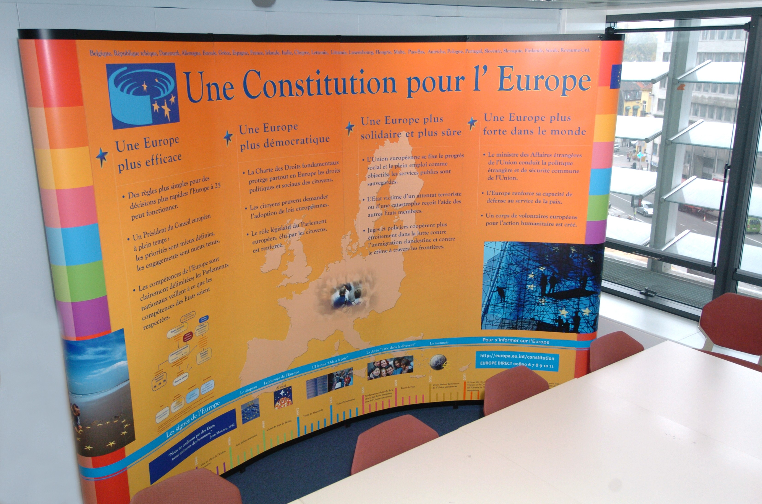

5. FACT SHEETS

24 fact sheets together with an index will explain theme-by-theme the main changes in the Constitution. This system was used when the Treaty of Nice was adopted. It is precise and detailed.

Publication: in the course of being prepared
These fact sheets will be available at the following addresses soon:
http://europa.eu.int/constitution/
or
http://www.europa.eu.int/scadplus

6. ACCESSORIES

The Commission has prepared certain other materials, which could be used in the framework of seminars/debates/conferences. They will be published in 20 languages, and contain the Constitution logo.

- Folders
- Stickers
- Promotional Post Cards
- Posters « A Constitution for Europe »

7. POWER POINT PRESENTATIONS

Two power point presentations have been published in order to explain the Constitution.

The first presentation is quite short (25 slides). It is available in 11 languages and aims to provide help to people giving conferences or to people who wish to know more about the Constitution quickly and simply.

A second presentation, available in English and in French, details the institutional architecture of the European Union as adopted by the Heads of States or government on 18 June 2004. It is intended for those who may have to make a presentation and who would like to present a precise aspect of Part I of the Constitution. He/she could therefore select slides of his/her choice (e.s: control of the application of the principle of subsidiarity; the legislative procedure; the role of the European Parliament etc..)
Both documents are available at the following address:
http://europa.eu.int/constitution/powerpoint_en.htm

These tools have been produced by the European Commission in cooperation with the Parliament, the Council, the Economic and Social Committee and the Committee of the Regions, in the name of the European Union, within the framework of the budgetary programme PRINCE.

