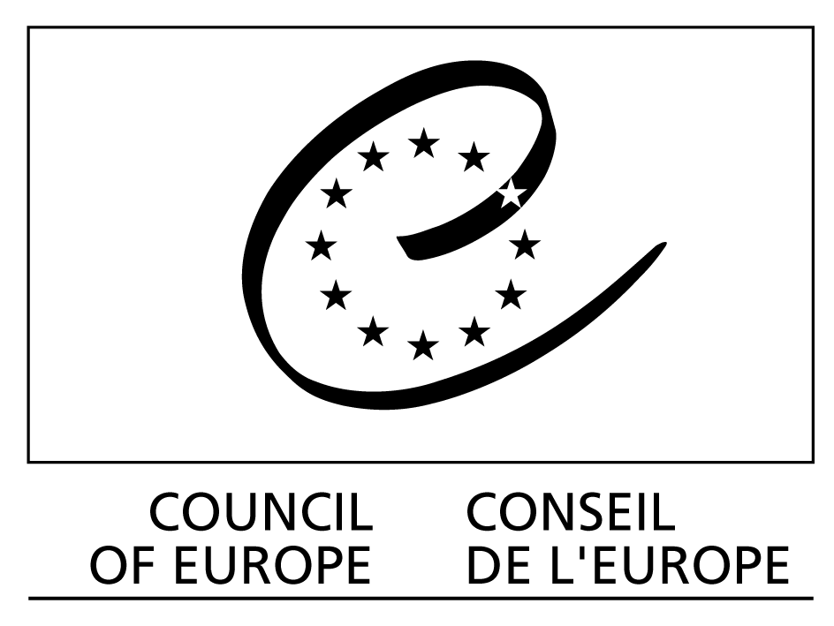


DJS/EYCB/HRE-NTC/2005/088 Budapest, 30 November 2005


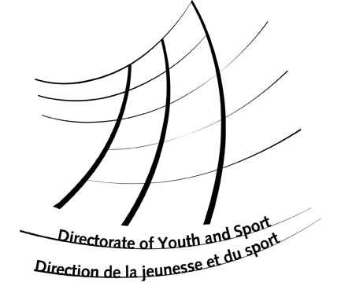

National
and Regional
Training Courses in Human Rights Education

2006 Programme

General Conditions and Guidelines for Applicants

Application form

National and regional training courses in human rights education within the Human Rights Education Youth Programme

The Directorate of Youth and Sport of the Council of Europe runs a European youth programme on human rights education since the year 2000, aiming to bring human rights issues in the mainstream of youth work practice. This programme is designed to achieve wide synergies between human rights education and youth work in the Council of Europe member states and beyond.

In 2002, the Council of Europe published “COMPASS – a manual on human rights education young people” in English. Presently, the manual is available also in Arabic, Bosnian, Bulgarian, Croatian, Dutch, French, Georgian, German, Hungarian, Italian, Polish, Romanian, Russian and Slovenian. Some six other language versions are either in the process of translation or being published.

In order to make COMPASS available and accessible to users across Europe, the Directorate of Youth and Sport supports the organisation of national and regional training courses in human rights education. These courses are means to introduce trainers, facilitators, youth workers and youth leaders, as well as professionals in formal education, to work with “COMPASS” and, consequently, mainstream human rights education in non-formal and formal education with young people. Forty-three such courses have been organised in 24 member states of the Council of Europe since 2002.

The organisation and implementation of these courses is possible only by and in close co-operation with national and regional institutions, organisations and public services interested in introducing and developing human rights education in non-formal and formal educational settings. The Council of Europe provides financial, educational and administrative support, but the ownership and organisation of the course relies on national partners.

The Council of Europe welcomes applications for further training courses in 2006 following the criteria and procedures outlined below.

Criteria and guidelines for national and regional training courses in human rights education for 2006

Profile of the partners

The Council of Europe welcomes proposals and expressions of interest from:
- Non-governmental youth organisations
- Other non-governmental and governmental organisations and institutions interested in human rights education with young people.

Priority will be given to:
- projects run in co-operation with different partners;
- projects in co-operation between the non-formal and formal educational fields;
- projects in countries/regions, where COMPASS is available in native language;
- projects in connection with launching events for COMPASS in translations.

General framework and conditions
- The training courses should aim at training multipliers (youth leaders, trainers, youth workers, teachers, teachers’ trainers) in developing human rights education activities with and for young people in their respective country/organisation;
- The courses should introduce the participants to “COMPASS” and how to work with it;
- The courses should bring together “key multipliers” of the country or region concerned, committed to carry out further activities and projects in human rights education with young people;
- The participants should come from a variety of associations and organisations dealing with human rights education and youth work (the courses should try to involve different religious, sexual, ethnic and cultural minorities and other frequently discriminated groups in society);
- The organisers should strive to achieve gender and geographical balance in the group of participants;
- The duration of the course, the number and profile of the participants should be consistent with programme and the specific objectives of the course. The courses should be held for a maximum of 40 participants, and have a minimum of 4 days duration;
- The courses should be held between April and December 2006.

The organisers are responsible for:
- defining the objectives for the course in the specific context of the country of the participants;
- preparing, running and evaluating the course with a competent team of trainers and organisers;
- providing the necessary infrastructure for a residential training course using educational methodology based on human rights education and principles of non-formal education;
- including, when appropriate, in the team of trainers one or more trainers who have participated in one of the courses “Training of Trainers in human rights education”, organised by the Directorate of Youth and Sports.

Support provided by Directorate of Youth and Sport of the Council of Europe

The Directorate of Youth and Sport of the Council of Europe may support the courses by providing:

Educational support and advice:
- Recommend or nominate trainer(s) with specialised experience in the field to support the national team of trainers in the programme development;
- Assist in designing the training course to the specific situation of the organising country/countries;
- Make available previous experience in the country or region.
and/or
Financial support to:
- Cover interpretation costs;
- Contribute to costs for board and lodging;
- Cover the travel costs of possible international participants;
- Cover the fees and expenses of trainers.
and/or

Institutional /educational support, such as:
- Recommendation letters to potential funding organisations
- Official Council of Europe representation at parts of the training course programme.
- Publicity of the training course at the Council of Europe Internet sites and publications;
- Authorisation for the organisers to use the logos of the Council of Europe and its Human Rights Education Youth Programme for the activity;
- Facilitating contacts with other institutions and organisations in the country already co-operating with the Council of Europe.

It is in the interest of the applicants to specify their needs and expectations towards the Council of Europe in the application form.

Procedure for applications

Interested organisations/institutions are requested to fill in the attached application form, specifying the support requested from the Council of Europe and send it by e-mail or post to the European Youth Centre Budapest before 31 January 2006.

The applicants will be informed about the success of their application before 15 March 2006.

The applications should be sent (by e-mail or post) to:

European Youth Centre Budapest at

H- 1024 Budapest - Zivatar utca 1-3
Tel + 36 1 4381030; Fax + 36 1 212 4076
e-mail: compass@coe.int
www.coe.int/hre

National and regional training courses in human rights education

Programme 2006
APPLICATION FORM
Please answer all questions clearly and concisely.
Add extra lines or pages as needed, but keep to the order of questions.

1. Name of the applicant organisation(s)

2. Details of the organisation(s)

Address:
Phone number: Fax number:
E-mail: Internet site:

3. Short description of the organisation (aims and main activities)

4. Contact person for this project (name and contact details)

5. Details on the training course
a) Title of the training course:
b) Starting date:
c) Ending date:
d) Number of working days:

6. Venue of the course (if possible, please provide the address and telephone/fax number)

7. Participants in the training
a) Total number of participants expected:
b) Expected average age of participants
c) The profile of participants (please provide details about their role in youth work and human rights education)

d) Describe briefly the planned procedure for recruiting participants

8. The training course is organised in co-operation with:

9. Team of trainers. Please provide details about the trainers including their specific fields of specialisation and competences

10. Aims and objectives of the course

11. Main issues addressed. Please indicate the main human rights/education issues that the course addresses

12. Programme outline – Please provide an outline of the daily programme envisaged

13. Preparation
Please explain briefly what kind of preparation you envisage, including dates of preparation meeting(s), if already available

14. Follow-up
How do you plan to follow up this training course (e.g. other training activities, ongoing contact with partner(s) and participants, etc)?

15. Type of support you request from the Directorate of Youth and Sport (For detailed information on the different types of assistance, please refer to page 3 of the presentation).

Educational support and advice
If yes, please specify your needs and expectations in accordance with the possibilities outlined in page 3

Financial assistance
If yes, please submit your detailed budget proposal.

Institutional / educational support please describe
If yes, please specify your needs and expectations in accordance with the possibilities outlined in page 3

16. Budget of the course
If you are requesting financial support, please present an estimated detailed budget of the total expenses and income of your project, indicating the amount of the grant requested from the Human Rights Education Youth Programme.
The budget must be submitted in Euro (€) and the total expenses must match the total income expected.

Please add extra rows to the table as needed.

Expenses | € (Euro)
- Board and lodging
- Interpretation costs
- Local travel
- Travel for international participants
- Production of documents
- Communication and co-ordination expenses
- Local trainers (please indicate number and rate))
- Other costs (please provide details)
TOTAL EXPENSES
Income | €(Euro)
- Contributions from participants and volunteers
- Contributions from local authorities
- Contribution from partner organisations
- Contributions from other public or private foundations (please specify)
- Contribution from the applicant organisation(s)
- Total amount requested from the Council of Europe HRE Youth Programme
Please specify, for which expenses you plan to use the Council of Europe’s contribution:
board and lodging costs
interpretation
local travel costs
travel costs of international participants
fees for locally recruited trainers
others (please specify)

TOTAL INCOME
Please submit this form until 31 January 2006 to:

Council of Europe, Directorate of Youth and Sport
European Youth Centre Budapest
H- 1024 Budapest, Hungary
Zivatar utca 1-3

Tel + 36 1 438 1030
Fax + 36 1 212 4076
e-mail: compass@coe.int

For further information, please consult our websites: www.coe.int/hre
A new course will be run in 2006 (6-15 March). Information about the course is available at the site: www.coe.int/hre The deadline for applications is 9 January 2006.
Financial support for courses is given only at the specific request of the organisers and only in a limited number of courses. Full financing of courses by the Council of Europe is not possible.

