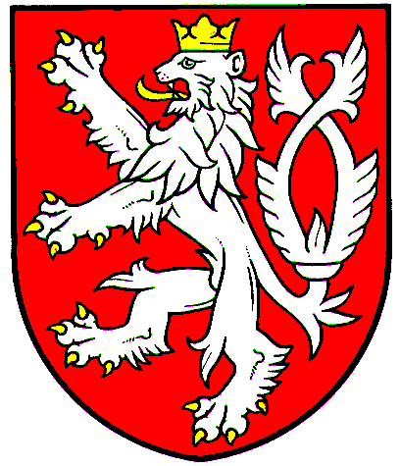

Pavel Doleček
Deputy Minister for Higher Education, Science and Research
Ministry of Education, Youth and Sports

Prague, November 2019
Ref. No.: MSMT-34020/2019-2

Dear Professor Breen,
Please be advised that due to organizational changes the Ministry of Education, Youth and Sports of the Czech Republic as the representing entity alters its representation to the General Assembly of the ESS ERIC.
In line with the Article 3/5 of the ESS ERIC Statues Mr Petr Ventluka is hereby replaced by new delegate Ms Kamila Gabrielová from the Ministry of Education, Youth and Sports; contact e-mail: kamila.gabrielova@msmt.cz, phone number +420 234 811 359.
This nomination is effective as of the date of signing of this deed.
Thank you for acknowledging this change of delegation.
Yours sincerely

Prof Michael Breen
Chair of the ESS ERIC General Assembly
City, University of London
Northampton Square
London, EC1V OHB
United Kingdom

Cc: Prof Rory Fitzgerald, Director of the ESS ERIC

