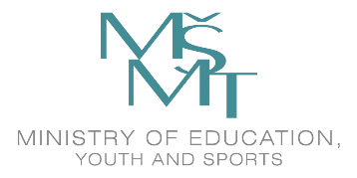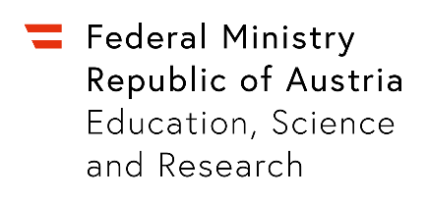

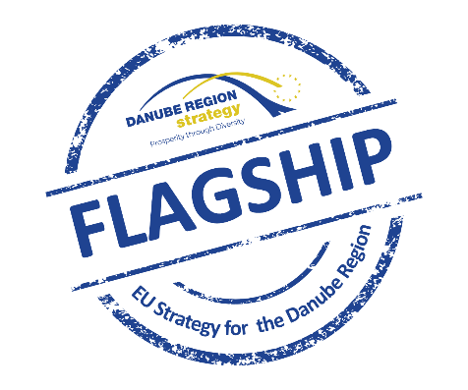

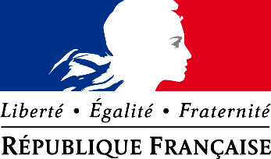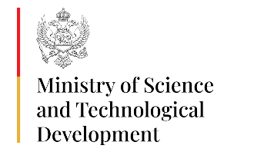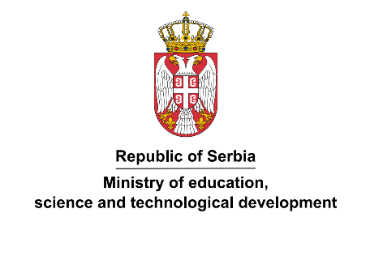

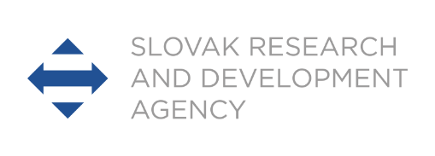

**REPUBLIC OF AUSTRIA / REPUBLIC OF BULGARIA / CZECH REPUBLIC**

**REPUBLIC OF FRANCE / MONTENEGRO / REPUBLIC OF SERBIA / SLOVAK REPUBLIC**

**MULTILATERAL SCIENTIFIC AND TECHNOLOGICAL COOPERATION IN THE DANUBE REGION**

**CALL FOR APPLICATIONS FOR 2023-2025 JOINT PROJECTS**

**CLOSING DATE: 16 JANUARY 2023**

**Aims of the Call**

* To contribute to scientific advancement in the abovementioned countries by funding researchers’ mobility in the frame of joint research projects;
* To contribute to research capacity development in the region;
* To support the advancement of cross-border research cooperation;
* To provide an opportunity for young/female researchers (as applicable) in the abovementioned countries to cooperate in an international setting and to develop their scientific careers;
* To facilitate the joint participation in European research projects.

**Areas of Cooperation**

The Call is open to all scientific disciplines and thematic areas, including social sciences as well as humanities.

**Duration of projects**

The projects will be supported for a period of max. 2 years from **July 2023** until **June 2025**.

**Target group**

**AUSTRIA:**

* **Researchers** at universities, universities of applied sciences and non-university research institutions in areas of basic research (minimum requirement Dr./PhD degree)
* **PhD/Doctoral students** (Bachelor and Master graduates are not eligible for funding)

**BULGARIA:** Detailed eligibility conditions are available at the web site of BNSF: [www.fni.bg](http://www.fni.bg).

***CZECH REPUBLIC*:** Researchers working atresearch organization in accordance with Art. 1.3 point. ee) Framework for State aid for research, development, and innovation (C(2022) 7388; 1.3, ff). Eligible research organisations are listed on this website: <http://www.msmt.cz/vyzkum-a-vyvoj-2/vyzkumne-organizace>. Minimum requirement for project members is a Master degree or equivalent.

***FRANCE:*** Eligibility criteria applied by the French evaluators are available on the website of Campus France under the following link: <https://www.campusfrance.org/fr/danube>

***MONTENEGRO*:** Researchers from Montenegro, taking part in this Programme, should be employees of Montenegrin scientific research institution licensed in accordance with Law on Scientific-Research Activities (Official Gazette of Montenegro, no. 80, 40/11, 57/14), and/or employees of Montenegrin innovation activity entities, registered in accordance with Law on Innovation Activities (Official Gazette of Montenegro, no. 82/20) – to be proved by a confirmation issued by the relevant institution/entity.

***REPUBLIC OF SERBIA*:**

* **Researchers** from Serbia who apply for the project should be persons in teaching, scientific and research positions who are employed in institutions of higher education and scientific research organisations in accordance with the Law on Science and Research ("Official Gazette of RS", No. 49/19) and participate in the implementation of the Institutional Financing Program or other programs of general interest in accordance with the Law. List of accredited scientific research organisation: <https://mpn.gov.rs/nauka/nauka-i-istrazivanje-u-srbiji/naucnoistrazivacke-organizacije/>
* "**Young researcher**" within the project team, means a person who meets the following conditions: has been selected for a research or scientific title or an equivalent title in higher education; obtained the PhD degree and has obtained a maximum of 10 years of research work, before the closing date of the Call and is employed in an accredited scientific research organisation.

***SLOVAK REPUBLIC*:** Any Slovak legal entity or Slovak natural person - an entrepreneur who holds valid certificate of competence to carry out research and development under § 26a sect. 11 or 12 of Act No. 172/2005 Coll. as amended.

**Application process and content**

It is up to the applicants to find suitable partners in participating partner countries. **Proposals must be submitted to all responsible national funding bodies of the participating partners simultaneously**. Proposals which have not been received by all participating partners will not be considered for funding. The call process is highly competitive therefore application does not guarantee funding.

***AUSTRIA:*** Electronic application only ***[***[***web-link***](https://asp.sop.co.at/oead/antrag?call=2023_MULT)***].***

Content: (in PDF format):

* Brief academic CV for each Austrian project member
* List of relevant publications of the last 2 years on the Austrian side
* Project description including methodology (3 to 5 A4 pages)
* Brief description of the partner institutions
* Short description of the project tasks of **ALL** project members (Austrian and other participating countries)
* Further cooperation perspective

**BULGARIA:** Proposals must be submitted online to the Management System of National Investments (NIMS) at the following address: <https://enims.egov.bg/>

***CZECH REPUBLIC*:** the application for the research project in English (unless otherwise specified) shall be preferably submitted via data box (MEYS data box: **vidaawt**). There must be a notice: „VYZVA 8X23 Danube - NEOTVIRAT“ in the data box message, in the column K rukám, please, fill “Oddělení 33”. The forms and other information are available on <http://www.msmt.cz/vyzkum-a-vyvoj-2/podunajska-spoluprace> (under the reference of the Call).

The application must include the following documents:

* Project Proposal (with project description including the methodology, description of the project tasks of all Czech project members; description of the partner institutions and further cooperation perspective) incl. Annex 1.
* Brief academic CV for each Czech project member
* List of relevant publications of the last 2 years

***FRANCE:*** the application must be submitted online on the following website: <https://www.campusfrance.org/fr/phc-candidater>.

***MONTENEGRO:*** the application for the research project must be submitted in both Englishand Montenegrin language, both in paper format and on a CD/DVD-Rom to the address below:

Ministry of Science and Technological Development

Department for International Cooperation

Rimski trg bb

81000 Podgorica

The electronic file **must** contain exactly the same application as the paper version enclosed.

The application must include the following:

* Project description including the objectives and methodological part (3 to 5 A4 pages);
* Brief academic CV for each Montenegrin project member;
* List of relevant publications of the last 2 years;
* Brief description of the partner institution
* Short description of the project tasks of **ALL** project members
* Expected project results and further cooperation perspective

***REPUBLIC OF SERBIA*:** Application must be submitted in Englishand Serbian languageonline at website: [www.mpn.gov.rs](http://www.mpn.gov.rs) The application must include the following information:

* Project description including the objectives and methodological part (3 to 5 A4 pages)
* Brief academic CV for each Serbian project member
* List of relevant publications of the last 5 years
* Brief description of the partner institution
* Short description of the project tasks of **ALL** project members
* Expected project results and further cooperation perspective

***SLOVAK REPUBLIC*:** the entire application for the research and development support project must be submitted in Slovak and Englishonline at [www.apvv.sk](http://www.apvv.sk) until call deadline. The application must include the following information:

* Brief academic information **for Slovak** **PI** and list of other project members
* List of relevant **Slovak PI** publications or important research results of the last 5 years
* Project description including the methodological part (3 to 5 A4 pages)
* Brief description of the partner institutions
* Short description of the project tasks of **ALL** project members
* Further cooperation perspective

**Funding**

The purpose of this call is to support the mobility of researchers among the participating countries to carry out joint research projects. In this regard, funding will be made available for visits and exchanges of scientists conducting joint research.

The sending state will cover the travel expenses as well as the accommodation costs and insurance of its own researchers.

In Austria in well-justified cases EUR 3,000.- per project may be applied for material and/or other costs.

In the Slovak Republic other costs associated with the project provided by the Agency in each financial year can be set at a minimum of EUR 100, while not exceeding 20% of the total project costs.

**Funding Modalities**

Funding will be available for a maximum of two years for **collaborative research projects** jointly developed and completed by researchers from a **minimum of 3 participating countries**.

Funding will be provided for activities within the scope of these guidelines only.

***AUSTRIA:***

|  |  |
| --- | --- |
| ***Number of participating countries*** | ***Maximum funding per project*** |
| **3** | **EUR 12,000.-** |
| **4** | **EUR 14,000.-** |
| **5** | **EUR 16,000.-** |
| **6 and more** | **EUR 18,000.-** |

Eligible Costs:

* Travel expenses: Travel costs (economy class) will be reimbursed based on submitted invoices. For travels up to seven hours bus and train shall be used.
* Accommodation expenses: *Researchers:* EUR 100.- per working day for up to 14 days OR EUR 1,400.- per month for long-term stays between 14 days and 3 months maximum. *PhD/Doctoral students*: EUR 100.- per working day for up to 12 days OR EUR 1,250.- per month for long-term stays between 12 days and 3 months maximum.
* Project related material costs: max. EUR 3000.- per project as part of the granted maximum budget based on submitted invoices.

***BULGARIA:***

Maximum funding for a project: - **BGN 40,000.-** (BGN 20,000.- per year)

The funding will be allocated as follows:

BGN 40,000, of which 60 % from the direct eligible cost are for mobility, and the rest funding is according to the specific rules of the BNSF for each project.

Detailed eligibility conditions are described in the GENERAL GUIDELINES AND PROCEDURES FOR EVALUATION OF PROCEDURE "CALLS FOR PROJECTS IN PROGRAMS FOR BILATERAL COOPERATION" and the Appendix 'Specific conditions’ for the International call for Multilateral scientific and technological cooperation in the Danube region,available at the web site of BNSF: [www.fni.bg](http://www.fni.bg).

***CZECH REPUBLIC*:**

|  |  |
| --- | --- |
| ***Number of participating countries*** | ***Maximum funding per project*** |
| ***3*** | **250 000 CZK (125 000 CZK per year)** |
| **4** | **300 000 CZK (150 000 CZK per year)** |
| **5 and more** | **350 000 CZK (175 000 CZK per year)** |

The funds can be calculated as follows:

* Travel expenses (including the costs of health insurance): maximum 7 000 CZK/person - per trip for Czech researchers travelling to an abovementioned country.
* Accommodation expenses (including food expenses according to the rules set by Ministry of Finance CR): Austria up to EUR 130.-, Bulgaria up to EUR 110,-, France up to EUR 150.-, Montenegro up to EUR 100,-, Serbia up to EUR 100.-, Slovakia up to EUR 110.-,  per person and per day for Czech researchers travelling to abovementioned countries for up to 14 days **OR** CZK 30 000.- per month for long-term visits between 15 days and 3 months maximum.

***FRANCE:***

|  |  |
| --- | --- |
| ***Number of participating countries*** | ***Maximum funding per project*** |
| **3** | **EUR 10,000.- (EUR 5,000.- per year)** |
| **4** | **EUR 12,500.- (EUR 6,250.- per year)** | |
| **5 and more** | **EUR 15,000.- (EUR 7,500.- per year)** | |

The funding will be allocated as follows:

* Travel costs will be reimbursed for French researchers travelling to an above-mentioned country based on submitted invoices: maximum EUR 500.- per trip
* Accommodation and food expenses: EUR 110.- flat rate per person and per day for French researchers travelling to an above-mentioned country

***MONTENEGRO*:**

|  |  |
| --- | --- |
| ***Number of participating countries*** | ***Maximum funding per project*** |
| **3** | **EUR 7,000.-** (EUR 3,500.- per year) |
| **4** | **EUR 8,500.-** (EUR 4.250,- per year) |
| **5 and more** | **EUR 10,000.-** (EUR 5.000,- per year) |

The funds can be allocated as follows:

* Travel expenses, including the costs of Health Insurance, will be reimbursed for Montenegrin researchers travelling to an abovementioned country based on submitted invoices: maximum EUR 400.- per trip
* Accommodation expenses: EUR 100.- per day for Montenegrin researchers travelling to an abovementioned country for up to 14 days or EUR 1,400.- per month for long-term visits between 15 days and 3 months maximum.

***REPUBLIC OF SERBIA*:**

|  |  |
| --- | --- |
| ***Number of participating countries*** | ***Maximum funding per project*** |
| **3** | **EUR 7,000.-** (EUR 3,500.- per year) |
| **4** | **EUR 8,500.-** (EUR 4.250,- per year) |
| **5 and more** | **EUR 9,000.-** (EUR 4.500,- per year) |

The funds can be calculated as follows:

* Travel expenses including the costs of Health Insurance will be reimbursed for Serbian researchers travelling to an abovementioned country based on submitted invoices: maximum EUR 400.- per trip
* Accommodation expenses: EUR 100.- per day for Serbian researchers travelling to an abovementioned country for up to 14 days or EUR 1,400.- per month for long-term visits between 15 days and 3 months maximum.

***SLOVAK REPUBLIC*:**

|  |  |  |
| --- | --- | --- |
| ***Number of participating countries*** | ***Maximum funding per project*** | |
| **3** | **EUR 10,000.-** (EUR 5,000.- per year) | |
| **4** | **EUR 12,500.-** (EUR 6,250.- per year) | |
| **5** | **EUR 15,000.-** (EUR 7,500.- per year) |
| **6 and more** | **EUR 17,500.-** (EUR 8,750.- per year) |

The funds can be calculated as follows:

* Travel expenses for Slovak researchers travelling on the territories of Slovakia and the participating partner countries, which are demonstrably related directly to the project.
* Accommodation expenses: for Slovak researchers travelling on the territories of Slovakia and the participating partner countries, which are demonstrably related directly to the project.
* Subsistence costs for Slovak researchers
* Documented necessary extra costs for Slovak researchers (visa, conference fees, travel health insurance abroad, tolls/fees and parking fees demonstrably related to the business trip covered within the project solution, compulsory and recommended vaccination, etc.)
* Other costs: minimum 100 EUR and maximum 30% from of the total project costs provided by the Agency in each financial year (material, services)

More details about Slovak national rules can be found in the consolidated version of the public call and their annex.

**Evaluation criteria**

Following the closing date of the call indicated below, applications will be submitted to recognized national experts in the various fields of research represented by the proposals received. These experts will evaluate each proposal based on the following criteria:

* Scientific value of the intended research project (Points 0-25)
* Feasibility of the joint research plan and adequacy of the scientific method (Points 0-15)
* Competence, expertise and complementarity of the scientists/research teams involved (Points 0-20)
* Added value expected from the multilateral research collaboration (Points 0-15)
* Potential for further or future European and international cooperation (Points 0-15)
* Participation of young research talents (5 Points / 10 Points for SK); gender balanced team (5 Points / 0 Points for SK) (Points 0-10)

Due to legal reasons, evaluation procedures within the Slovak Research and Development Agency (SRDA) only foresee an evaluation regarding the participation of young research talent in this category.

A maximum of 100 points can be achieved.

**Funding decision**

Following national evaluation, a joint shortlist of projects to be funded will be constituted through consultations between the implementing agencies/ministries based on the results of the national evaluations. The project selection will be carried out by the funding agencies and ministries of the participating countries. The results of the project selection meeting will be announced presumably by June 2023.

**Reporting and Publications**

**Scientific and financial reporting on the project is obligatory.**

* A final scientific and financial report has to be submitted in English (for Slovakian partners only in Slovak) by all project partners to their national implementation agencies/ministries no more than 30 days after the end of the project.
* The report has to mention outputs of the projects compared with the objectives and aims of the proposal.
* Joint publications by researchers have to mention the support from the respective funding agencies/ministries.

**Additionally in Austria:** A brief project progress report has to be submitted after one year via the OeAD GmbH online tool as a precondition for further funding.

**Additionally in France:** A scientific and financial progress report has to be submitted after one year to the French embassies (please see contacts below) as a precondition for further funding.

**Additionally in Serbia:** A scientific and financial progress report has to be submitted after one year to the Ministry of Education, Science and Technological Development as a precondition for further funding.

**Additionally in the Slovak Republic**: A brief project progress report has to be submitted online and per regular post after one year to the Slovak Research and Development Agency as a precondition for further funding.

**Intellectual property**

The researchers of each country must take adequate steps to ensure protection and sharing of the intellectual property that could result from the joint projects.

**Closing date for applications**

Applications must be submitted before **16 January 2023**. Applications received after this date will not be considered for funding.

Please note that the implementing agencies/ministries will not be held responsible for applications that were not received. Principal Investigators have to ensure that their research partners submit their applications in time.

**Further information**

|  |  |
| --- | --- |
| **For Austria** | **For Bulgaria** |
| OeAD-GmbH (Austrian Agency for International Cooperation in Education and Research)  **Isabella Scheibelreiter** Ebendorferstraße 7 A-1010 Vienna Tel.: +43 (0)1/ 53408-472 E-mail: [wtz@oead.at](mailto:wtz@oead.at) | BNSF - Bulgarian National Science Fund  Bilateral and International cooperation  **Mrs. Lyubomira Hristova**  Al. Stamboliyski Blvd., 239 B,  1309 Sofia  Tel. +359 884 222 393  Email: [l.gyneva@mon.bg](mailto:l.gyneva@mon.bg) |

|  |  |
| --- | --- |
| **For Czech Republic** | **For the Republic of France** |
| Ministry of Education Youth and Sports  Management of International R&D Programmes Unit  **Luděk Kos**  Karmelitská 529/5  118 12 PRAHA 1  Tel.: +420 234 812 299  E-mail: ludek.kos@msmt.cz | Ministère de l’Europe et des Affaires étrangères  Policy Officer for Higher education and research in Europe  **Solveig Gathelier**  27 rue de la Convention  75015 Paris  E-Mail: [solveig.gathelier@diplomatie.gouv.fr](mailto:solveig.gathelier@diplomatie.gouv.fr) |

|  |  |
| --- | --- |
| **For Montenegro** | **For the Republic of Serbia** |
| Ministry of Science and Technological Development  Department for International Cooperation  **Ms. Ivana Lagator**  Rimski trg bb  81000 Podgorica, Montenegro  Tel: +382 20 405 326  E-mail: [ivana.lagator@mpnks.gov.me](mailto:ivana.lagator@mpnks.gov.me)  **Ms. Lidija Vukčević**  Rimski trg bb  81000 Podgorica, Montenegro  Tel: +382 20 405 344  E-mail: [lidija.vukcevic@mpnks.gov.me](mailto:lidija.vukcevic@mpnks.gov.me) | Ministry of Education, Science and Technological Development  **Snežana Omić**  22-26, Nemanjina St.  11 000 Belgrade  Tel.: +381 11 3616 589  E-mail: [snezana.omic@mpn.gov.rs](mailto:snezana.omic@mpn.gov.rs) |

|  |
| --- |
| **For Slovak Republic** |
| SRDA (Slovak Research and Development Agency)  Department of International Cooperation  **JUDr. Stanislav Mydlo**  Mýtna 23, P.O.BOX 839 04  839 04 Bratislava  Tel.: +421 2 5720 4101  E-mail: [stanislav.mydlo@apvv.sk](mailto:anna.durfina@apvv.sk) |