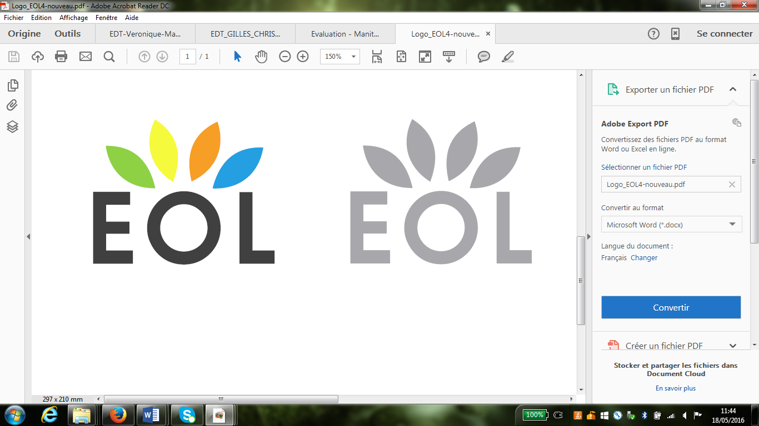 | ECML Training & Consultancy  Czech Republic  2023 | 
Deadline: 25th May 2023

Name and function:
E-mail:

- Please give us a short overview of your school and/or your territory
Name of the school + city
Information about the students (how many, age, etc.)

Key purposes / objectives of your school

Main challenges

Language(s) taught | Language(s) of schooling:  Other languages:
Are there any other languages which are used in your school (by students, parents, teachers)?
Special educational offer (in Sports, Sciences, Economy, Culture, etc.)
International mobility programmes and partnerships
Digital equipment and classroom design

Information about the town and the region

- List five words or phrases that you associate with a “learning environment”

- Would you say the learning environment in your school / territory is language friendly?
Explain why.

- What are your expectations and needs for the Training and Consultancy session?

- Your photos: Please insert, entitle and comment two photos from your school / territory

Photo 1: formal learning situation  (classroom, reading corner, in/outdoor learning etc.) | Photo 2: non-formal language learning situation  (outside school, e.g.in the city, etc.).
Title of the photo | Title of the photo
Information about this photo | Information about this photo
Could this photo be published on the EOL website or used for other TaC session?  □ Yes □ No | Could this photo be published on the EOL website or used for other TaC session?  □ Yes □ No

