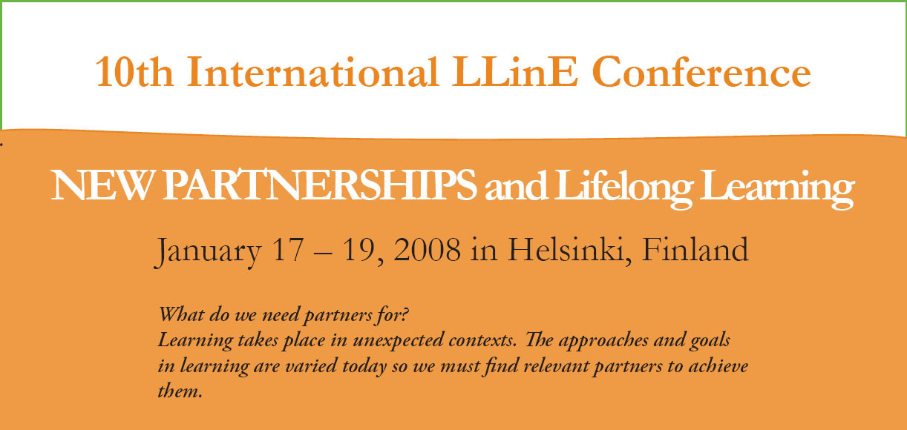

The early bird registration for the 10th International LLinE Conference is open until November 15, 2007.
You can register on-line at www.lline.fi
Posters and exhibition at the Conference Fair
An opportunity to introduce your project at the Conference Fair. Bring information materials!
Combine your project meeting with the LLine Conference
Call for papers - Send an abstract of 200 words by November 15, 2007
research, case studies and projects on new innovative partnerships combining:
work, learning and family; education and entrepreneurship; multicultural society and learning communities; partners for learning regions.
More information: Kaisa-Leena Juvonen, KVS Foundation (Kansanvalistusseura) conference@kvs.fi; www.lline.fi

