Practical information

Conference Venue
Dbb forum berlin
Friedrichstraße 169/170
D-10117 Berlin
Telefon: 030.4081 – 4500
http://www.dbb-forum-berlin.de/default.htm

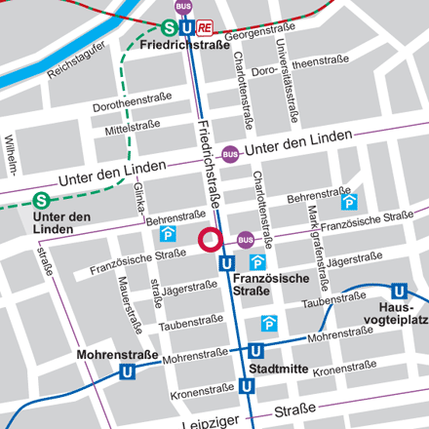

Registration & Conferences Fees
In order to register for the conference we kindly ask you to fill in the attached registration from. The registration form can either been faxed (+49/228/2690639) or sent via email (danja.oste@studentenwerke.de). Online registration is not possible.

Conference fees are €€€€€€ 150,- and cover the participation in the conference program and the social programme (as described below).

Registration for the conference is open until May 11, 2007!

All payments must be made in EURO by back transfer. Unfortunately, online payment by credit card is not possible for technical reasons. An invoice will be sent to you after your registration in order to process the payment for your registration fee.

Cancellation Policy
All cancellations and changes must be submitted in writing to the Deutsches Studentenwerk by e-mail (danja.oste@studentenwerke.de) or fax (+49/228/2690639)

If a cancellation is received before 18 May 2007 the registration fee will be refunded after the conference. If cancellation is received after 18 May 2007 and/or the participant fails to attend, the entire fee has to be paid. Substitutes will be accepted at any time provided that the Deutsches Studentenwerk is informed about the change.

Accommodation
A number of rooms have been blocked in several hotels. The conference venue is easily reachable from all hotels listed. Participants are kindly asked to book their room themselves. Please remember to mention “DSW” when booking a hotel room. All rooms are blocked until May 11, 2007 (except the ApartHotel which is blocked until April 6, 2007). Make sure that you meet the reservation deadline as hotels in Berlin are nearly fully booked due to a multiplicity of events within the German EU-Presidency.

Hotel ibis am Ostbahnhof (40 Zimmer rooms blocked)
An der Schillingbrucke 2, 10243 Berlin
Phone: + 49(30) 257600, Fax : + 49(30) 25760333
E-Mail: h3108-re@accor.com
www.accorhotels.com
Rate: €€ 80,50 for single room per night, breakfast included

Relexa Hotel Stuttgarter Hof (10 rooms blocked)

Anhalterstraße 8-9, 10963 Berlin
Phone: + 49(30) 26 48 30, Fax: + 49(30) 26 483-900
Internet: www.relax-hotels.de
Rate: €€€€ 100,00 for single room per night, breakfast included

- Hotel Allegra (10 rooms blocked)
Albrechtstraße 17 , 10117 Berlin
Phone +49 (30) 3 08 86-0, Fax +49 (30) 3 08 86-100
E-Mail: allegra@albrechtshof-hotels.de
Internet: www.hotel-allegra.de
Rate: €€€€ 85,00 for single room per night, breakfast included

- NH Berlin –Mitte (20 rooms blocked)
Leipziger Straße 106-111, 10117 Berlin
Phone: +49 (30) 206 207 91, Fax: +49 (30) 206 207 80
E-Mail: f.lueck@nh-hotels.com
Internet: www.nh-hotels.com
Rate: €€€€ 140,00 for single room per night, breakfast included
DSW reservation number: 40.012.592

- ApartHotel Residenz Am Deutschen Theater (10 rooms blocked until 6.4.07)
Reinhardstraße 27a - 31, 10117 Berlin,
Phone + 49(30) 28 00 810, Fax: +49(30) 28 00 81 999,
E-Mail: info@aparthotel-redidenz.de
Internet: www.aparthotel-residenz.de
Rate: €€€€ 99,00 for single room per night

Travel information: How to get to Berlin

By plane
Berlin can easily be reached by plane from all destinations due to a well established national and international air route system. You will either arrive at the airport Tegel (TXL) or Schönefeld (SXF). Both airports are well connected to the public transport system.
For more information please check the following websites:
http://www.berlin.de/english/visitors/getting_here_away/index.html
http://www.berlin.de/english/visitors/getting_around/index.html

By train
Berlin can be reached from all destinations using the InterCityExpress-, InterCity-, EuroCity- and InterRegio Trains.
For more information please check the following websites:
http://www.berlin.de/english/visitors/getting_here_away/index.html
http://www.berlin.de/english/visitors/getting_around/index.html

Weather conditions
Weather forecast: http://wetter.rtl.de/

Dress code
During the conference the dress code is business casual. Do not forget to bring a comfortable outfit for your leisure time activities!

Social programme
- For those of you interested in getting to know the city of Berlin a bit better we will arrange for thematic sight seeing walks (English tour guides). The sight seeing walking tours will take place on Sunday 10 June at 2:30 pm to ~5 pm. We will charge an extra fee of 10,- Euro for the tours. Please sign up for the tour in your registration form. Information on the meeting point will be sent to you after registration.

- On Sunday 10 June 2007 a welcome reception for all attends will be held at the “Dbb forum berlin” , Friedrichstraße 169/170, 10117 Berlin at 7 pm. The reception is included in the conference fee; however we kindly request you to register for participation.

- On Monday 11 June 2007 at 7 pm we will arrange for a boat trip on the river Spree. The conference dinner will take place on the boat. The dinner is included in the conference fees, but we kindly ask you to register for participation.

Contact
For enquiries regarding the programme or registration, please contact:

Deutsches Studentenwerk
Ms Danja Oste
Head of Unit, International Relations
Weberstrasse 55
53113 Bonn
Tel: +49/228/269 06 42
Fax: +49/228/ 269 06 39
E-mai: danja.oste@studentenwerke.de

